What is Git?

Git is a popular version control system. It was created by Linus Torvalds in 2005, and has been maintained by Junio Hamano since then.

It is used for:

* Tracking code changes
* Tracking who made changes
* Coding collaboration

What does Git do?

* Manage projects with **Repositories**
* **Clone** a project to work on a local copy
* Control and track changes with **Staging** and **Committing**
* **Branch** and **Merge** to allow for work on different parts and versions of a project
* **Pull** the latest version of the project to a local copy
* **Push** local updates to the main project

Working with Git

* Initialize Git on a folder, making it a **Repository**
* Git now creates a hidden folder to keep track of changes in that folder
* When a file is changed, added or deleted, it is considered **modified**
* You select the modified files you want to **Stage**
* The **Staged** files are **Committed**, which prompts Git to store a **permanent** snapshot of the files
* Git allows you to see the full history of every commit.
* You can revert back to any previous commit.
* Git does not store a separate copy of every file in every commit, but keeps track of changes made in each commit!

### Why Git?

* Over 70% of developers use Git!
* Developers can work together from anywhere in the world.
* Developers can see the full history of the project.
* Developers can revert to earlier versions of a project.

### What is GitHub?

* Git is not the same as GitHub.
* GitHub makes tools that use Git.
* GitHub is the largest host of source code in the world, and has been owned by Microsoft since 2018.
* In this tutorial, we will focus on using Git with GitHub.

## Git Install

You can download Git for free from the following website: [httpges://www.git-scm.com/](https://git-scm.com/)

## Using Git with Command Line

To start using Git, we are first going to open up our Command shell.

For Windows, you can use Git bash, which comes included in Git for Windows. For Mac and Linux you can use the built-in terminal.

The first thing we need to do, is to check if Git is properly installed:

### Example

git --version

git version 2.30.2.windows.1

If Git is installed, it should show something like git version X.Y

## Configure Git

Now let Git know who you are. This is important for version control systems, as each Git commit uses this information:

### Example

git config --global user.name "w3schools-test"

git config --global user.email "test@w3schools.com"

Change the user name and e-mail address to your own. You will probably also want to use this when registering to GitHub later on.

**Note:** Use global to set the username and e-mail for **every repository** on your computer.

If you want to set the username/e-mail for just the current repo, you can remove global

## Creating Git Folder

Now, let's create a new folder for our project:

### Example

mkdir myproject

cd myproject

mkdir **make**s a **new directory**.

cd **changes** the **current working directory**.

Now that we are in the correct directory. We can start by initializing Git!

**Note:** If you already have a folder/directory you would like to use for Git:

Navigate to it in command line, or open it in your file explorer, right-click and select "Git Bash here"

## Initialize Git

Once you have navigated to the correct folder, you can initialize Git on that folder:

### Example

git init

Initialized empty Git repository in /Users/user/myproject/.git/

## Git Adding New Files

You just created your first local Git repo. But it is empty.

So let's add some files, or create a new file using your favourite text editor. Then save or move it to the folder you just created.

If you want to learn how to create a new file using a text editor, you can visit our HTML tutorial:  
[HTML Editors](https://www.w3schools.com/html/html_editors.asp)

For this example, I am going to use a simple HTML file like this:

### Example

<!DOCTYPE html>  
<html>  
<head>  
<title>Hello World!</title>  
</head>  
<body>  
  
<h1>Hello world!</h1>  
<p>This is the first file in my new Git Repo.</p>  
  
</body>  
</html>

And save it to our new folder as index.html.

Let's go back to the terminal and list the files in our current working directory:

### Example

ls

index.html

ls will **list** the files in the directory. We can see that index.html is there.

Then we check the Git status and see if it is a part of our repo:

### Example

git status

On branch master

No commits yet

Untracked files:

  (use "git add ..." to include in what will be committed)

    index.html

nothing added to commit but untracked files present (use "git add" to track)

Now Git is **aware** of the file, but has not **added** it to our repository!

Files in your Git repository folder can be in one of 2 states:

* Tracked - files that Git knows about and are added to the repository
* Untracked - files that are in your working directory, but not added to the repository

 When you first add files to an empty repository, they are all untracked. To get Git to track them, you need to stage them, or add them to the staging environment.

We will cover the staging environment in the next chapter.

## Git Adding New Files

You just created your first local Git repo. But it is empty.

So let's add some files, or create a new file using your favourite text editor. Then save or move it to the folder you just created.

If you want to learn how to create a new file using a text editor, you can visit our HTML tutorial:  
[HTML Editors](https://www.w3schools.com/html/html_editors.asp)

For this example, I am going to use a simple HTML file like this:

### Example

<!DOCTYPE html>  
<html>  
<head>  
<title>Hello World!</title>  
</head>  
<body>  
  
<h1>Hello world!</h1>  
<p>This is the first file in my new Git Repo.</p>  
  
</body>  
</html>

And save it to our new folder as index.html.

Let's go back to the terminal and list the files in our current working directory:

### Example

ls

index.html

ls will **list** the files in the directory. We can see that index.html is there.

Then we check the Git status and see if it is a part of our repo:

### Example

git status

On branch master

No commits yet

Untracked files:

  (use "git add ..." to include in what will be committed)

    index.html

nothing added to commit but untracked files present (use "git add" to track)

Now Git is **aware** of the file, but has not **added** it to our repository!

Files in your Git repository folder can be in one of 2 states:

* Tracked - files that Git knows about and are added to the repository
* Untracked - files that are in your working directory, but not added to the repository

 When you first add files to an empty repository, they are all untracked. To get Git to track them, you need to stage them, or add them to the staging environment.

We will cover the staging environment in the next chapter.

## Git Staging Environment

One of the core functions of Git is the concepts of the Staging Environment, and the Commit.

As you are working, you may be adding, editing and removing files. But whenever you hit a milestone or finish a part of the work, you should add the files to a Staging Environment.

**Staged** files are files that are ready to be **committed** to the repository you are working on. You will learn more about commit shortly.

For now, we are done working with index.html. So we can add it to the Staging Environment:

### Example

git add index.html

The file should be **Staged**. Let's check the status::

### Example

git status

On branch master

No commits yet

Changes to be committed:

  (use "git rm --cached ..." to unstage)

    new file: index.html

Now the file has been added to the Staging Environment.

## Git Add More than One File

You can also stage more than one file at a time. Let's add 2 more files to our working folder. Use the text editor again.

A README.md file that describes the repository (recommended for all repositories):

### Example

# hello-world  
Hello World repository for Git tutorial  
This is an example repository for the Git tutoial on https://www.w3schools.com  
  
This repository is built step by step in the tutorial.

A basic external style sheet (bluestyle.css):

### Example

body {  
background-color: lightblue;  
}  
  
h1 {  
color: navy;  
margin-left: 20px;  
}

And update index.html to include the stylesheet:

### Example

<!DOCTYPE html>  
<html>  
<head>  
<title>Hello World!</title>  
<link rel="stylesheet" href="bluestyle.css">  
</head>  
<body>  
  
<h1>Hello world!</h1>  
<p>This is the first file in my new Git Repo.</p>  
  
</body>  
</html>

Now add all files in the current directory to the Staging Environment:

### Example

git add --all

Using --all instead of individual filenames will stage all changes (new, modified, and deleted) files.

### Example

git status

On branch master

No commits yet

Changes to be committed:

(use "git rm --cached ..." to unstage)

new file: README.md

new file: bluestyle.css

new file: index.html

Now all 3 files are added to the Staging Environment, and we are ready to do our first commit.

**Note:** The shorthand command for git add --all is git add -A

## Git Commit

Since we have finished our work, we are ready move from stage to commit for our repo.

Adding commits keep track of our progress and changes as we work. Git considers each commit change point or "save point". It is a point in the project you can go back to if you find a bug, or want to make a change.

When we commit, we should **always** include a **message**.

By adding clear messages to each commit, it is easy for yourself (and others) to see what has changed and when.

### Example

git commit -m "First release of Hello World!"

[master (root-commit) 221ec6e] First release of Hello World!

3 files changed, 26 insertions(+)

create mode 100644 README.md

create mode 100644 bluestyle.css

create mode 100644 index.html

The commit command performs a commit, and the -m "message" adds a message.

The Staging Environment has been committed to our repo, with the message:  
"First release of Hello World!"

## Git Commit without Stage

Sometimes, when you make small changes, using the staging environment seems like a waste of time. It is possible to commit changes directly, skipping the staging environment. The -a option will automatically stage every changed, already tracked file.

Let's add a small update to index.html:

### Example

<!DOCTYPE html>  
<html>  
<head>  
<title>Hello World!</title>  
<link rel="stylesheet" href="bluestyle.css">  
</head>  
<body>  
  
<h1>Hello world!</h1>  
<p>This is the first file in my new Git Repo.</p>  
<p>A new line in our file!</p>  
  
</body>  
</html>

And check the status of our repository. But this time, we will use the --short option to see the changes in a more compact way:

### Example

git status --short

M index.html

**Note:** Short status flags are:

* ?? - Untracked files
* A - Files added to stage
* M - Modified files
* D - Deleted files

We see the file we expected is modified. So let's commit it directly:

### Example

git commit -a -m "Updated index.html with a new line"

[master 09f4acd] Updated index.html with a new line

1 file changed, 1 insertion(+)

**Warning:** Skipping the Staging Environment is not generally recommended.

Skipping the stage step can sometimes make you include unwanted changes.

## Git Commit Log

To view the history of commits for a repository, you can use the log command:

### Example

git log

commit 09f4acd3f8836b7f6fc44ad9e012f82faf861803 (HEAD -> master)

Author: w3schools-test

Date: Fri Mar 26 09:35:54 2021 +0100

Updated index.html with a new line

commit 221ec6e10aeedbfd02b85264087cd9adc18e4b26

Author: w3schools-test

Date: Fri Mar 26 09:13:07 2021 +0100

First release of Hello World!

## Git Help

If you are having trouble remembering commands or options for commands, you can use Git help.

There are a couple of different ways you can use the help command in command line:

* git command -help -  See all the available options for the specific command
* git help --all -  See all possible commands

 Let's go over the different commands.

## Git -help See Options for a Specific Command

Any time you need some help remembering the specific option for a command, you can use git command -help:

### Example

git commit -help

usage: git commit [] [--] ...

-q, --quiet suppress summary after successful commit

-v, --verbose show diff in commit message template

Commit message options

-F, --file read message from file

--author override author for commit

--date override date for commit

-m, --message

commit message

-c, --reedit-message

reuse and edit message from specified commit

-C, --reuse-message

reuse message from specified commit

--fixup use autosquash formatted message to fixup specified commit

--squash use autosquash formatted message to squash specified commit

--reset-author the commit is authored by me now (used with -C/-c/--amend)

-s, --signoff add a Signed-off-by trailer

-t, --template

use specified template file

-e, --edit force edit of commit

--cleanup how to strip spaces and #comments from message

--status include status in commit message template

-S, --gpg-sign[=]

GPG sign commit

Commit contents options

-a, --all commit all changed files

-i, --include add specified files to index for commit

--interactive interactively add files

-p, --patch interactively add changes

-o, --only commit only specified files

-n, --no-verify bypass pre-commit and commit-msg hooks

--dry-run show what would be committed

--short show status concisely

--branch show branch information

--ahead-behind compute full ahead/behind values

--porcelain machine-readable output

--long show status in long format (default)

-z, --null terminate entries with NUL

--amend amend previous commit

--no-post-rewrite bypass post-rewrite hook

-u, --untracked-files[=]

show untracked files, optional modes: all, normal, no. (Default: all)

--pathspec-from-file

read pathspec from file

--pathspec-file-nul with --pathspec-from-file, pathspec elements are separated with NUL character

**Note:** You can also use --help instead of -help to open the relevant Git manual page

## Git help --all See All Possible Commands

To list all possible commands, use the help --all command:

**Warning:** This will display a very long list of commands

### Example

$ git help --all

See 'git help ' to read about a specific subcommand

Main Porcelain Commands

add Add file contents to the index

am Apply a series of patches from a mailbox

archive Create an archive of files from a named tree

bisect Use binary search to find the commit that introduced a bug

branch List, create, or delete branches

bundle Move objects and refs by archive

checkout Switch branches or restore working tree files

cherry-pick Apply the changes introduced by some existing commits

citool Graphical alternative to git-commit

clean Remove untracked files from the working tree

clone Clone a repository into a new directory

commit Record changes to the repository

describe Give an object a human readable name based on an available ref

diff Show changes between commits, commit and working tree, etc

fetch Download objects and refs from another repository

format-patch Prepare patches for e-mail submission

gc Cleanup unnecessary files and optimize the local repository

gitk The Git repository browser

grep Print lines matching a pattern

gui A portable graphical interface to Git

init Create an empty Git repository or reinitialize an existing one

log Show commit logs

maintenance Run tasks to optimize Git repository data

merge Join two or more development histories together

mv Move or rename a file, a directory, or a symlink

notes Add or inspect object notes

pull Fetch from and integrate with another repository or a local branch

push Update remote refs along with associated objects

range-diff Compare two commit ranges (e.g. two versions of a branch)

rebase Reapply commits on top of another base tip

reset Reset current HEAD to the specified state

restore Restore working tree files

revert Revert some existing commits

rm Remove files from the working tree and from the index

shortlog Summarize 'git log' output

show Show various types of objects

sparse-checkout Initialize and modify the sparse-checkout

stash Stash the changes in a dirty working directory away

status Show the working tree status

submodule Initialize, update or inspect submodules

switch Switch branches

tag Create, list, delete or verify a tag object signed with GPG

worktree Manage multiple working trees

Ancillary Commands / Manipulators

config Get and set repository or global options

fast-export Git data exporter

fast-import Backend for fast Git data importers

filter-branch Rewrite branches

mergetool Run merge conflict resolution tools to resolve merge conflicts

pack-refs Pack heads and tags for efficient repository access

prune Prune all unreachable objects from the object database

reflog Manage reflog information

remote Manage set of tracked repositories

repack Pack unpacked objects in a repository

replace Create, list, delete refs to replace objects

Ancillary Commands / Interrogators

annotate Annotate file lines with commit information

blame Show what revision and author last modified each line of a file

bugreport Collect information for user to file a bug report

count-objects Count unpacked number of objects and their disk consumption

difftool Show changes using common diff tools

fsck Verifies the connectivity and validity of the objects in the database

gitweb Git web interface (web frontend to Git repositories)

help Display help information about Git

instaweb Instantly browse your working repository in gitweb

merge-tree Show three-way merge without touching index

rerere Reuse recorded resolution of conflicted merges

show-branch Show branches and their commits

verify-commit Check the GPG signature of commits

verify-tag Check the GPG signature of tags

whatchanged Show logs with difference each commit introduces

Interacting with Others

archimport Import a GNU Arch repository into Git

cvsexportcommit Export a single commit to a CVS checkout

cvsimport Salvage your data out of another SCM people love to hate

cvsserver A CVS server emulator for Git

imap-send Send a collection of patches from stdin to an IMAP folder

p4 Import from and submit to Perforce repositories

quiltimport Applies a quilt patchset onto the current branch

request-pull Generates a summary of pending changes

send-email Send a collection of patches as emails

svn Bidirectional operation between a Subversion repository and Git

Low-level Commands / Manipulators

apply Apply a patch to files and/or to the index

checkout-index Copy files from the index to the working tree

commit-graph Write and verify Git commit-graph files

commit-tree Create a new commit object

hash-object Compute object ID and optionally creates a blob from a file

index-pack Build pack index file for an existing packed archive

merge-file Run a three-way file merge

merge-index Run a merge for files needing merging

mktag Creates a tag object

mktree Build a tree-object from ls-tree formatted text

multi-pack-index Write and verify multi-pack-indexes

pack-objects Create a packed archive of objects

prune-packed Remove extra objects that are already in pack files

read-tree Reads tree information into the index

symbolic-ref Read, modify and delete symbolic refs

unpack-objects Unpack objects from a packed archive

update-index Register file contents in the working tree to the index

update-ref Update the object name stored in a ref safely

write-tree Create a tree object from the current index

Low-level Commands / Interrogators

cat-file Provide content or type and size information for repository objects

cherry Find commits yet to be applied to upstream

diff-files Compares files in the working tree and the index

diff-index Compare a tree to the working tree or index

diff-tree Compares the content and mode of blobs found via two tree objects

for-each-ref Output information on each ref

for-each-repo Run a Git command on a list of repositories

get-tar-commit-id Extract commit ID from an archive created using git-archive

ls-files Show information about files in the index and the working tree

ls-remote List references in a remote repository

ls-tree List the contents of a tree object

merge-base Find as good common ancestors as possible for a merge

name-rev Find symbolic names for given revs

pack-redundant Find redundant pack files

rev-list Lists commit objects in reverse chronological order

rev-parse Pick out and massage parameters

show-index Show packed archive index

show-ref List references in a local repository

unpack-file Creates a temporary file with a blob's contents

var Show a Git logical variable

verify-pack Validate packed Git archive files

Low-level Commands / Syncing Repositories

daemon A really simple server for Git repositories

fetch-pack Receive missing objects from another repository

http-backend Server side implementation of Git over HTTP

send-pack Push objects over Git protocol to another repository

update-server-info Update auxiliary info file to help dumb servers

Low-level Commands / Internal Helpers

check-attr Display gitattributes information

check-ignore Debug gitignore / exclude files

check-mailmap Show canonical names and email addresses of contacts

check-ref-format Ensures that a reference name is well formed

column Display data in columns

credential Retrieve and store user credentials

credential-cache Helper to temporarily store passwords in memory

credential-store Helper to store credentials on disk

fmt-merge-msg Produce a merge commit message

interpret-trailers Add or parse structured information in commit messages

mailinfo Extracts patch and authorship from a single e-mail message

mailsplit Simple UNIX mbox splitter program

merge-one-file The standard helper program to use with git-merge-index

patch-id Compute unique ID for a patch

sh-i18n Git's i18n setup code for shell scripts

sh-setup Common Git shell script setup code

stripspace Remove unnecessary whitespace

External commands

askyesno

credential-helper-selector

## **flow**Working with Git Branches

In Git, a branch is a new/separate version of the main repository.

Let's say you have a large project, and you need to update the design on it.

How would that work without and with Git:

Without Git:

* Make copies of all the relevant files to avoid impacting the live version
* Start working with the design and find that code depend on code in other files, that also need to be changed!
* Make copies of the dependant files as well. Making sure that every file dependency references the correct file name
* EMERGENCY! There is an unrelated error somewhere else in the project that needs to be fixed ASAP!
* Save all your files, making a note of the names of the copies you were working on
* Work on the unrelated error and update the code to fix it
* Go back to the design, and finish the work there
* Copy the code or rename the files, so the updated design is on the live version
* (2 weeks later, you realize that the unrelated error was not fixed in the new design version because you copied the files before the fix)

With Git:

* With a new branch called new-design, edit the code directly without impacting the main branch
* EMERGENCY! There is an unrelated error somewhere else in the project that needs to be fixed ASAP!
* Create a new branch from the main project called small-error-fix
* Fix the unrelated error and merge the small-error-fix branch with the main branch
* You go back to the new-design branch, and finish the work there
* Merge the new-design branch with main (getting alerted to the small error fix that you were missing)

Branches allow you to work on different parts of a project without impacting the main branch.

When the work is complete, a branch can be merged with the main project.

You can even switch between branches and work on different projects without them interfering with each other.

Branching in Git is very lightweight and fast!

## New Git Branch

Let add some new features to our index.html page.

We are working in our local repository, and we do not want to disturb or possibly wreck the main project.

So we create a new branch:

### Example

git branch hello-world-images

Now we created a new branch called "hello-world-images"

Let's confirm that we have created a new branch:

### Example

git branch

hello-world-images

* master

We can see the new branch with the name "hello-world-images", but the * beside master specifies that we are currently on that branch.

checkout is the command used to check out a branch. Moving us **from** the current branch, **to** the one specified at the end of the command:

### Example

git checkout hello-world-images

Switched to branch 'hello-world-images'

Now we have moved our current workspace from the master branch, to the new branch

Open your favourite editor and make some changes.

For this example, we added an image (img_hello_world.jpg) to the working folder and a line of code in the index.html file:

### Example

<!DOCTYPE html>  
<html>  
<head>  
<title>Hello World!</title>  
<link rel="stylesheet" href="bluestyle.css">  
</head>  
<body>  
  
<h1>Hello world!</h1>  
<div><img src="img_hello_world.jpg" alt="Hello World from Space"  
style="width:100%;max-width:960px"></div>  
<p>This is the first file in my new Git Repo.</p>  
<p>A new line in our file!</p>  
  
</body>  
</html>

We have made changes to a file and added a new file in the working directory (same directory as the main branch).

Now check the status of the current branch:

### Example

git status

On branch hello-world-images

Changes not staged for commit:

(use "git add ..." to update what will be committed)

(use "git restore ..." to discard changes in working directory)

modified: index.html

Untracked files:

(use "git add ..." to include in what will be committed)

img_hello_world.jpg

no changes added to commit (use "git add" and/or "git commit -a")

So let's go through what happens here:

* There are changes to our index.html, but the file is not staged for commit
* img_hello_world.jpg is not tracked

So we need to add both files to the Staging Environment for this branch:

### Example

git add --all

Using --all instead of individual filenames will **Stage** all changed (new, modified, and deleted) files.

Check the status of the branch:

### Example

git status

On branch hello-world-images

Changes to be committed:

  (use "git restore --staged ..." to unstage)

    new file: img_hello_world.jpg

    modified: index.html

We are happy with our changes. So we will commit them to the branch:

### Example

git commit -m "Added image to Hello World"

[hello-world-images 0312c55] Added image to Hello World

2 files changed, 1 insertion(+)

create mode 100644 img_hello_world.jpg

Now we have a new branch, that is different from the master branch.

**Note:** Using the -b option on checkout will create a new branch, and move to it, if it does not exist

lfs

**Note:** If you find yourself stuck in the list view, SHIFT + G to jump the end of the list, then q to exit the view.

## Switching Between Branches

Now let's see just how quick and easy it is to work with different branches, and how well it works.

We are currently on the branch hello-world-images. We added an image to this branch, so let's list the files in the current directory:

### Example

ls

README.md bluestyle.css img_hello_world.jpg index.html

We can see the new file img_hello_world.jpg, and if we open the html file, we can see the code has been altered. All is as it should be.

Now, let's see what happens when we change branch to master

### Example

git checkout master

Switched to branch 'master'

The new image is not a part of this branch. List the files in the current directory again:

### Example

ls

README.md bluestyle.css index.html

img_hello_world.jpg is no longer there! And if we open the html file, we can see the code reverted to what it was before the alteration.

See how easy it is to work with branches? And how this allows you to work on different things?

## Emergency Branch

Now imagine that we are not yet done with hello-world-images, but we need to fix an error on master.

I don't want to mess with master directly, and I do not want to mess with hello-world-images, since it is not done yet.

So we create a new branch to deal with the emergency:

### Example

git checkout -b emergency-fix

Switched to a new branch 'emergency-fix'

Now we have created a new branch from master, and changed to it. We can safely fix the error without disturbing the other branches.

Let's fix our imaginary error:

### Example

<!DOCTYPE html>  
<html>  
<head>  
<title>Hello World!</title>  
<link rel="stylesheet" href="bluestyle.css">  
</head>  
<body>  
  
<h1>Hello world!</h1>  
<p>This is the first file in my new Git Repo.</p>  
<p>This line is here to show how merging works.</p>  
  
</body>  
</html>

We have made changes in this file, and we need to get those changes to the master branch.

Check the status:

### Example

git status

On branch emergency-fix

Changes not staged for commit:

(use "git add ..." to update what will be committed)

(use "git restore ..." to discard changes in working directory)

modified: index.html

no changes added to commit (use "git add" and/or "git commit -a")

stage the file, and commit:

### Example

git add index.html

git commit -m "updated index.html with emergency fix"

[emergency-fix dfa79db] updated index.html with emergency fix

1 file changed, 1 insertion(+), 1 deletion(-)

Now we have a fix ready for master, and we need to merge the two branches.

Top of Form

## Test Yourself With Exercises

Bottom of Form

## Merge Branches

We have the emergency fix ready, and so let's merge the master and emergency-fix branches.

First, we need to change to the master branch:

### Example

git checkout master

Switched to branch 'master'

Now we merge the current branch (master) with emergency-fix:

### Example

git merge emergency-fix

Updating 09f4acd..dfa79db

Fast-forward

index.html | 2 +-

1 file changed, 1 insertion(+), 1 deletion(-)

Since the emergency-fix branch came directly from master, and no other changes had been made to master while we were working, Git sees this as a continuation of master. So it can "Fast-forward", just pointing both master and emergency-fix to the same commit.

As master and emergency-fix are essentially the same now, we can delete emergency-fix, as it is no longer needed:

### Example

git branch -d emergency-fix

Deleted branch emergency-fix (was dfa79db).

## Merge Conflict

Now we can move over to hello-world-images and keep working. Add another image file (img_hello_git.jpg) and change index.html, so it shows it:

### Example

git checkout hello-world-images

Switched to branch 'hello-world-images'

### Example

<!DOCTYPE html>  
<html>  
<head>  
<title>Hello World!</title>  
<link rel="stylesheet" href="bluestyle.css">  
</head>  
<body>  
  
<h1>Hello world!</h1>  
<div><img src="img_hello_world.jpg" alt="Hello World from Space" style="width:100%;max-width:960px"></div>  
<p>This is the first file in my new Git Repo.</p>  
<p>A new line in our file!</p>  
<div><img src="img_hello_git.jpg" alt="Hello Git" style="width:100%;max-width:640px"></div>  
  
</body>  
</html>

Now, we are done with our work here and can stage and commit for this branch:

### Example

git add --all

git commit -m "added new image"

[hello-world-images 1f1584e] added new image

2 files changed, 1 insertion(+)

create mode 100644 img_hello_git.jpg

We see that index.html has been changed in both branches. Now we are ready to merge hello-world-images into master. But what will happen to the changes we recently made in master?

### Example

git checkout master

git merge hello-world-images

Auto-merging index.html

CONFLICT (content): Merge conflict in index.html

Automatic merge failed; fix conflicts and then commit the result.

The merge failed, as there is conflict between the versions for index.html. Let us check the status:

### Example

git status

On branch master

You have unmerged paths.

(fix conflicts and run "git commit")

(use "git merge --abort" to abort the merge)

Changes to be committed:

new file: img_hello_git.jpg

new file: img_hello_world.jpg

Unmerged paths:

(use "git add ..." to mark resolution)

both modified: index.html

This confirms there is a conflict in index.html, but the image files are ready and staged to be committed.

So we need to fix that conflict. Open the file in our editor:

### Example

<!DOCTYPE html>  
<html>  
<head>  
<title>Hello World!</title>  
<link rel="stylesheet" href="bluestyle.css">  
</head>  
<body>  
  
<h1>Hello world!</h1>  
<div><img src="img_hello_world.jpg" alt="Hello World from Space" style="width:100%;max-width:960px"></div>  
<p>This is the first file in my new Git Repo.</p>  
<<<<<<< HEAD  
<p>This line is here to show how merging works.</p>  
=======  
<p>A new line in our file!</p>  
<div><img src="img_hello_git.jpg" alt="Hello Git" style="width:100%;max-width:640px"></div>  
>>>>>>> hello-world-images  
  
</body>  
</html>

We can see the differences between the versions and edit it like we want:

### Example

<!DOCTYPE html>  
<html>  
<head>  
<title>Hello World!</title>  
<link rel="stylesheet" href="bluestyle.css">  
</head>  
<body>  
  
<h1>Hello world!</h1>  
<div><img src="img_hello_world.jpg" alt="Hello World from Space" style="width:100%;max-width:960px"></div>  
<p>This is the first file in my new Git Repo.</p>  
<p>This line is here to show how merging works.</p>  
<div><img src="img_hello_git.jpg" alt="Hello Git" style="width:100%;max-width:640px"></div>  
  
</body>  
</html>

Now we can stage index.html and check the status:

### Example

git add index.html

git status

On branch master

All conflicts fixed but you are still merging.

(use "git commit" to conclude merge)

Changes to be committed:

new file: img_hello_git.jpg

new file: img_hello_world.jpg

modified: index.html

The conflict has been fixed, and we can use commit to conclude the merge:

### Example

git commit -m "merged with hello-world-images after fixing conflicts"

[master e0b6038] merged with hello-world-images after fixing conflicts

And delete the hello-world-images branch:

### Example

git branch -d hello-world-images

Deleted branch hello-world-images (was 1f1584e).

Now you have a better understanding of how branches and merging works. Time to start working with a remote repository!

## GitHub Account

Go to [GitHub](https://www.github.com/) and sign up for an account:



**Note:** Remember to use the same e-mail address you used in the Git config.

## Create a Repository on GitHub

Now that you have made a GitHub account, sign in, and create a new Repo:

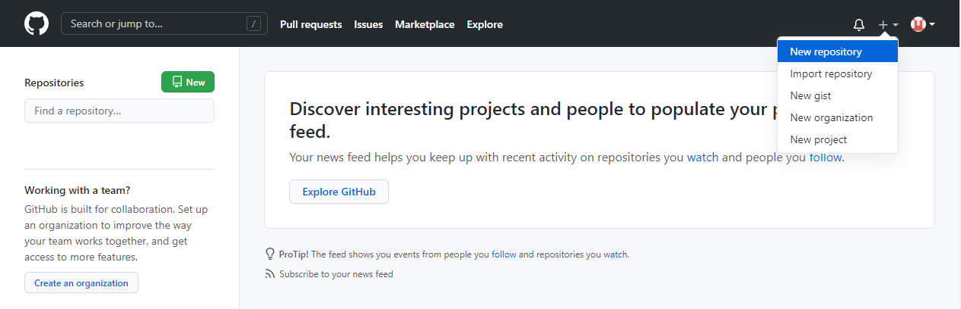

And fill in the relevant details:

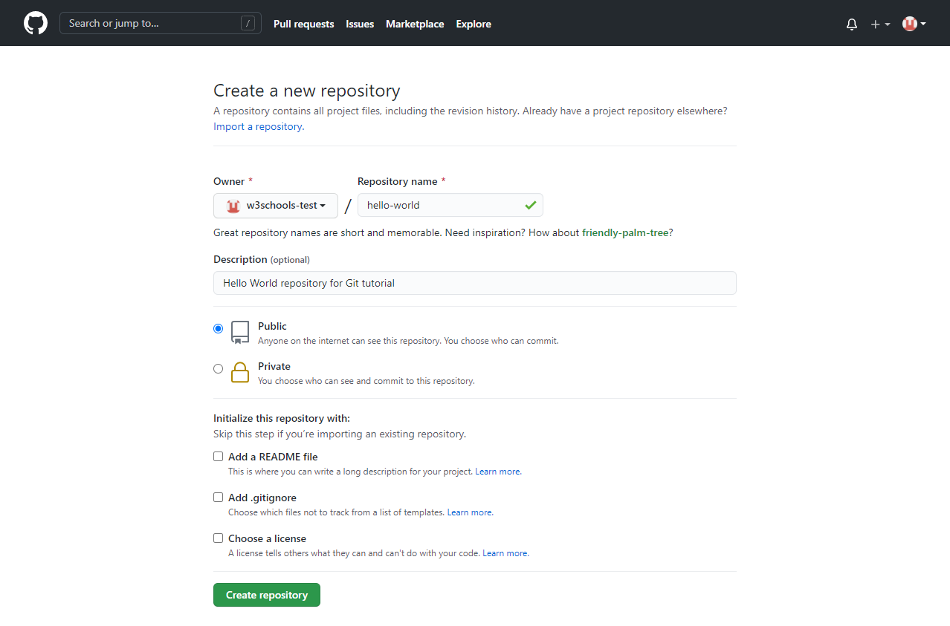

We will go over the different options and what they mean later. But for now, choose Public (if you want the repo to be viewable for anyone) or Private (if you want to choose who should be able to view the repo). Either way, you will be able to choose who can **contribute** to the repo.

Then click "Create repository".

## Push Local Repository to GitHub

Since we have already set up a local Git repo, we are going to push that to GitHub:

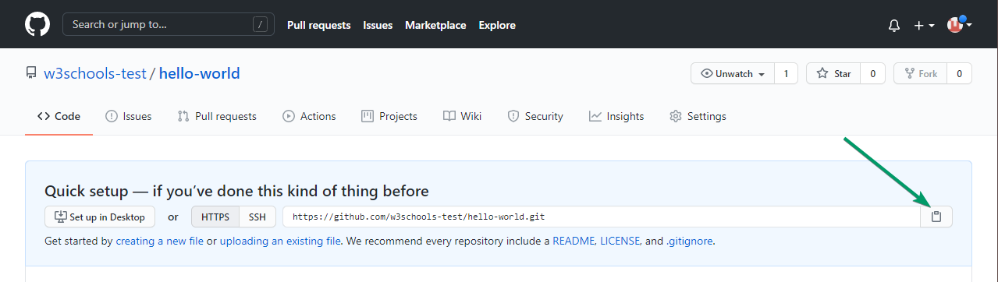

Copy the URL, or click the clipboard marked in the image above.

Now paste it the following command:

### Example

git remote add origin https://github.com/w3schools-test/hello-world.git

git remote add origin URL specifies that you are adding a remote repository, with the specified URL, as an origin to your local Git repo.

Now we are going to push our master branch to the origin url, and set it as the default remote branch:

### Example

git push --set-upstream origin master

Enumerating objects: 22, done.

Counting objects: 100% (22/22), done.

Delta compression using up to 16 threads

Compressing objects: 100% (22/22), done.

Writing objects: 100% (22/22), 92.96 KiB | 23.24 MiB/s, done.

Total 22 (delta 11), reused 0 (delta 0), pack-reused 0

remote: Resolving deltas: 100% (11/11), done.

To https://github.com/w3schools-test/hello-world.git

* [new branch] master -> master

Branch 'master' set up to track remote branch 'master' from 'origin'.

**Note:** Since this is the first time you are connecting to GitHub, you will get some kind of notification you to authenticate this connection.

Now, go back into GitHub and see that the repository has been updated:

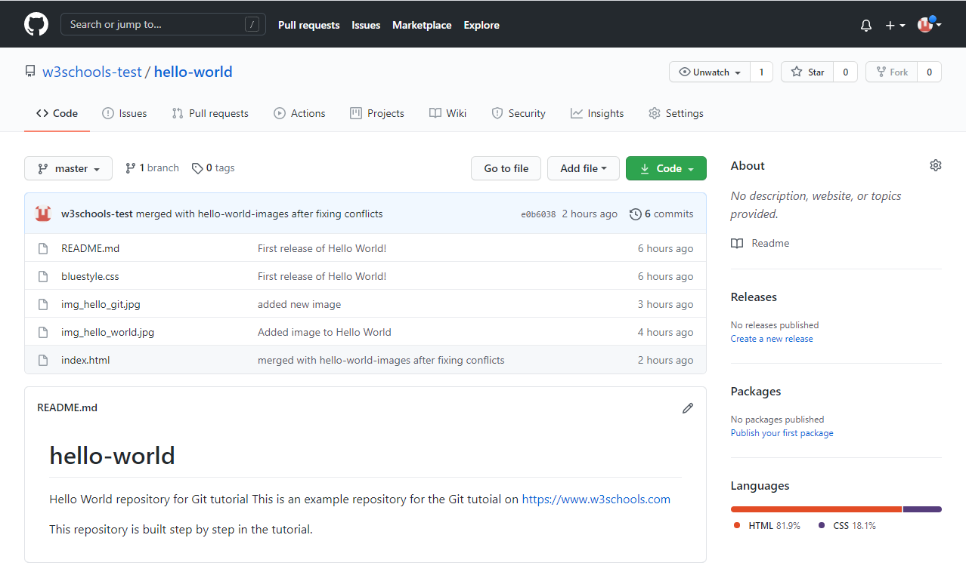

Top of Form

## Test Yourself With Exe

## Edit Code in GitHub

In addition to being a host for Git content, GitHub has a very good code editor.

Let's try to edit the README.md file in GitHub. Just click the edit button:

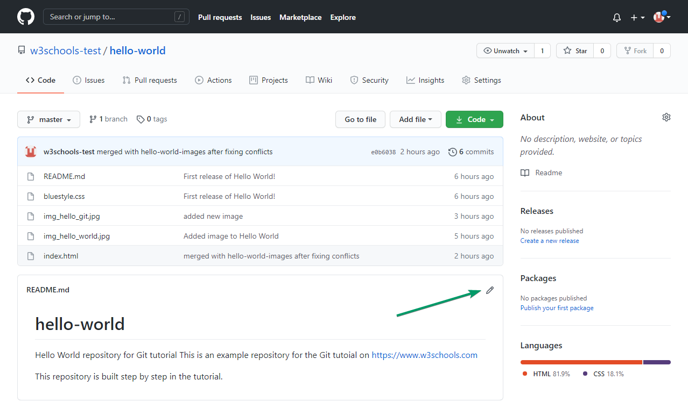

Add some changes to the code, and then commit the changes. For now, we will "Commit directly to the master branch".

Remember to add a description for the commit:

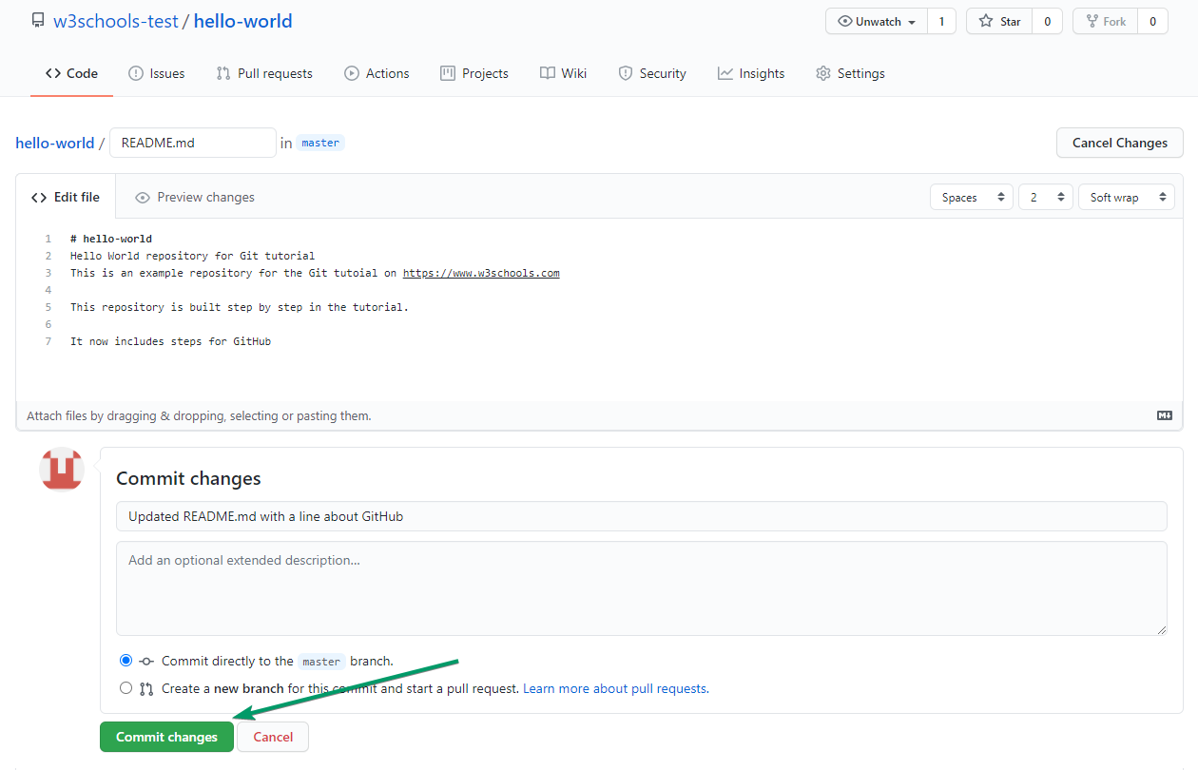

# That is how you edit code directly in GitHub!

# **Git Pull from GitHub**

## Pulling to Keep up-to-date with Changes

When working as a team on a project, it is important that everyone stays up to date.

Any time you start working on a project, you should get the most recent changes to your local copy.

With Git, you can do that with pull.

pull is a combination of 2 different commands:

* fetch
* merge

Let's take a closer look into how fetch, merge, and pull works.

## Git Fetch

fetch gets all the change history of a tracked branch/repo.

So, on your local Git, fetch updates to see what has changed on GitHub:

### Example

git fetch origin

remote: Enumerating objects: 5, done.

remote: Counting objects: 100% (5/5), done.

remote: Compressing objects: 100% (3/3), done.

remote: Total 3 (delta 2), reused 0 (delta 0), pack-reused 0

Unpacking objects: 100% (3/3), 733 bytes | 3.00 KiB/s, done.

From https://github.com/w3schools-test/hello-world

e0b6038..d29d69f master -> origin/master

Now that we have the recent changes, we can check our status:

### Example

git status

On branch master

Your branch is behind 'origin/master' by 1 commit, and can be fast-forwarded.

(use "git pull" to update your local branch)

nothing to commit, working tree clean

We are behind the origin/master by 1 commit. That should be the updated README.md, but lets double check by viewing the log:

### Example

git log origin/master

commit d29d69ffe2ee9e6df6fa0d313bb0592b50f3b853 (origin/master)

Author: w3schools-test <77673807+w3schools-test@users.noreply.github.com>

Date: Fri Mar 26 14:59:14 2021 +0100

Updated README.md with a line about GitHub

commit e0b6038b1345e50aca8885d8fd322fc0e5765c3b (HEAD -> master)

Merge: dfa79db 1f1584e

Author: w3schools-test

Date: Fri Mar 26 12:42:56 2021 +0100

merged with hello-world-images after fixing conflicts

...

...

That looks as expected, but we can also verify by showing the differences between our local master and origin/master:

### Example

git diff origin/master

diff --git a/README.md b/README.md

index 23a0122..a980c39 100644

--- a/README.md

+++ b/README.md

@@ -2,6 +2,4 @@

Hello World repository for Git tutorial

This is an example repository for the Git tutoial on https://www.w3schools.com

-This repository is built step by step in the tutorial.

-

-It now includes steps for GitHub

+This repository is built step by step in the tutorial.

\ No newline at end of file

That looks precisely as expected! Now we can safely merge.

## Git Merge

merge combines the current branch, with a specified branch.

We have confirmed that the updates are as expected, and we can merge our current branch (master) with origin/master:

### Example

git merge origin/master

Updating e0b6038..d29d69f

Fast-forward

README.md | 4 +++-

1 file changed, 3 insertions(+), 1 deletion(-)

Check our status again to confirm we are up to date:

### Example

git status

On branch master

Your branch is up to date with 'origin/master'.

nothing to commit, working tree clean

There! Your local git is up to date!

## Git Pull

But what if you just want to update your local repository, without going through all those steps?

pull is a combination of fetch and merge. It is used to pull all changes from a remote repository into the branch you are working on.

Make another change to the Readme.md file on GitHub.

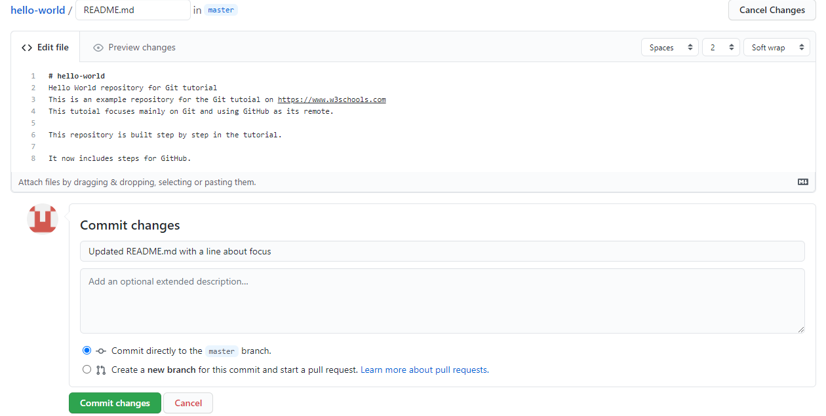

Use pull to update our local Git:

### Example

git pull origin

remote: Enumerating objects: 5, done.

remote: Counting objects: 100% (5/5), done.

remote: Compressing objects: 100% (3/3), done.

remote: Total 3 (delta 1), reused 0 (delta 0), pack-reused 0

Unpacking objects: 100% (3/3), 794 bytes | 1024 bytes/s, done.

From https://github.com/w3schools-test/hello-world

a7cdd4b..ab6b4ed master -> origin/master

Updating a7cdd4b..ab6b4ed

Fast-forward

README.md | 2 ++

1 file changed, 2 insertions(+)

That is how you keep your local Git up to date from a remote repository. In the next chapter, we will look closer at how push works on GitHub.

## Push Changes to GitHub

Let's try making some changes to our local git and pushing them to GitHub.

### Example

<!DOCTYPE html>  
<html>  
<head>  
<title>Hello World!</title>  
<link rel="stylesheet" href="bluestyle.css">  
</head>  
<body>  
  
<h1>Hello world!</h1>  
<div><img src="img_hello_world.jpg" alt="Hello World from Space" style="width:100%;max-width:640px"></div>  
<p>This is the first file in my new Git Repo.</p>  
<p>This line is here to show how merging works.</p>  
<div><img src="img_hello_git.jpg" alt="Hello Git" style="width:100%;max-width:640px"></div>  
  
</body>  
</html>

Commit the changes:

### Example

git commit -a -m "Updated index.html. Resized image"

[master e7de78f] Updated index.html. Resized image

1 file changed, 1 insertion(+), 1 deletion(-)

And check the status:

### Example

git status

On branch master

Your branch is ahead of 'origin/master' by 1 commit.

(use "git push" to publish your local commits)

nothing to commit, working tree clean

Now push our changes to our remote origin:

### Example

git push origin

Enumerating objects: 9, done.

Counting objects: 100% (8/8), done.

Delta compression using up to 16 threads

Compressing objects: 100% (5/5), done.

Writing objects: 100% (5/5), 578 bytes | 578.00 KiB/s, done.

Total 5 (delta 3), reused 0 (delta 0), pack-reused 0

remote: Resolving deltas: 100% (3/3), completed with 3 local objects.

To https://github.com/w3schools-test/hello-world.git

5a04b6f..facaeae master -> master

Go to GitHub, and confirm that the repository has a new commit:

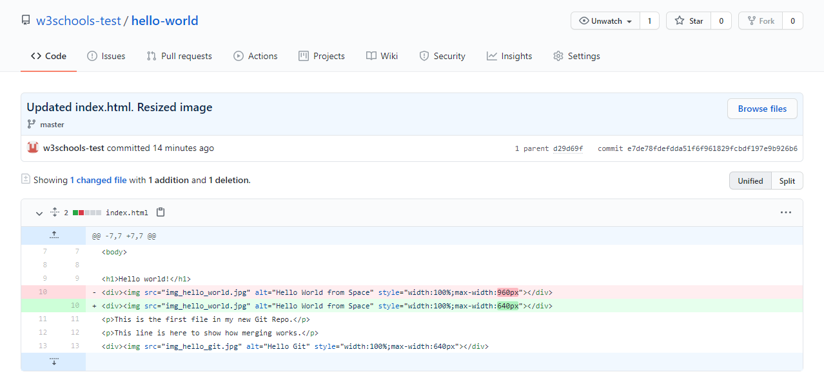

Now, we are going to start working on branches on GitHub.

## Create a New Branch on GitHub

On GitHub, access your repository and click the "master" branch button.

There you can create a new Branch. Type in a descriptive name, and click Create branch:

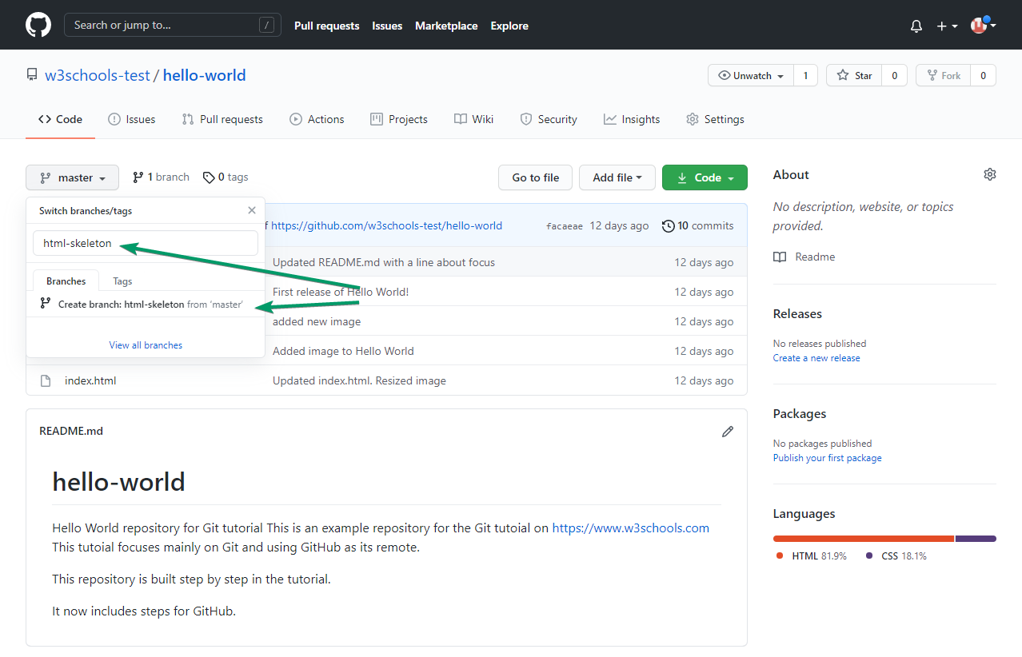

The branch should now be created and active. You can confirm which branch you are working on by looking at the branch button. See that it now says "html-skeleton" instead of "main"?

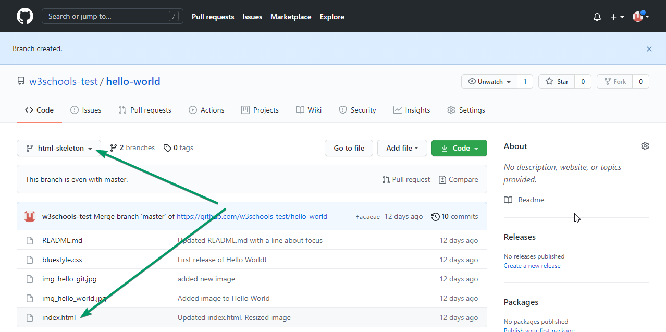

Start working on an existing file in this branch. Click the "index.html" file and start editing:

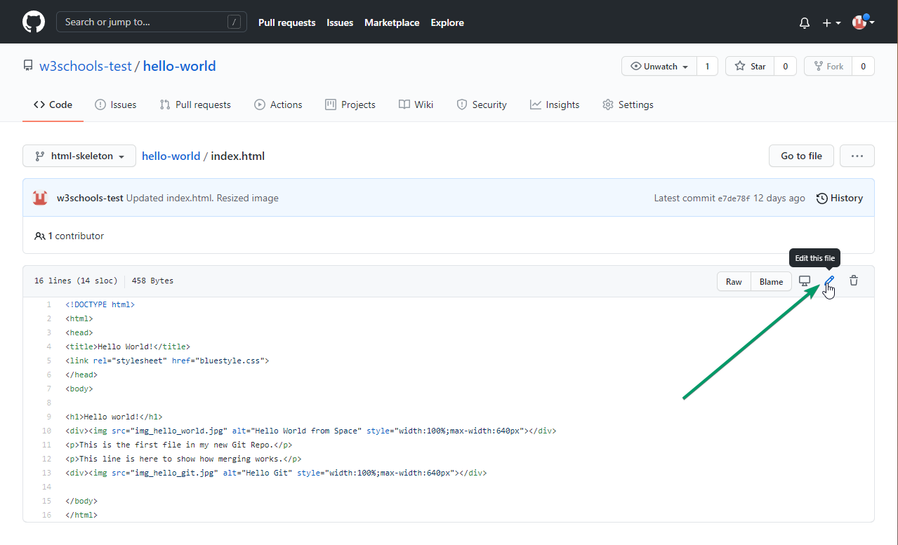

After you have finished editing the file, you can click the "Preview changes" tab to see the changes you made highlighted:

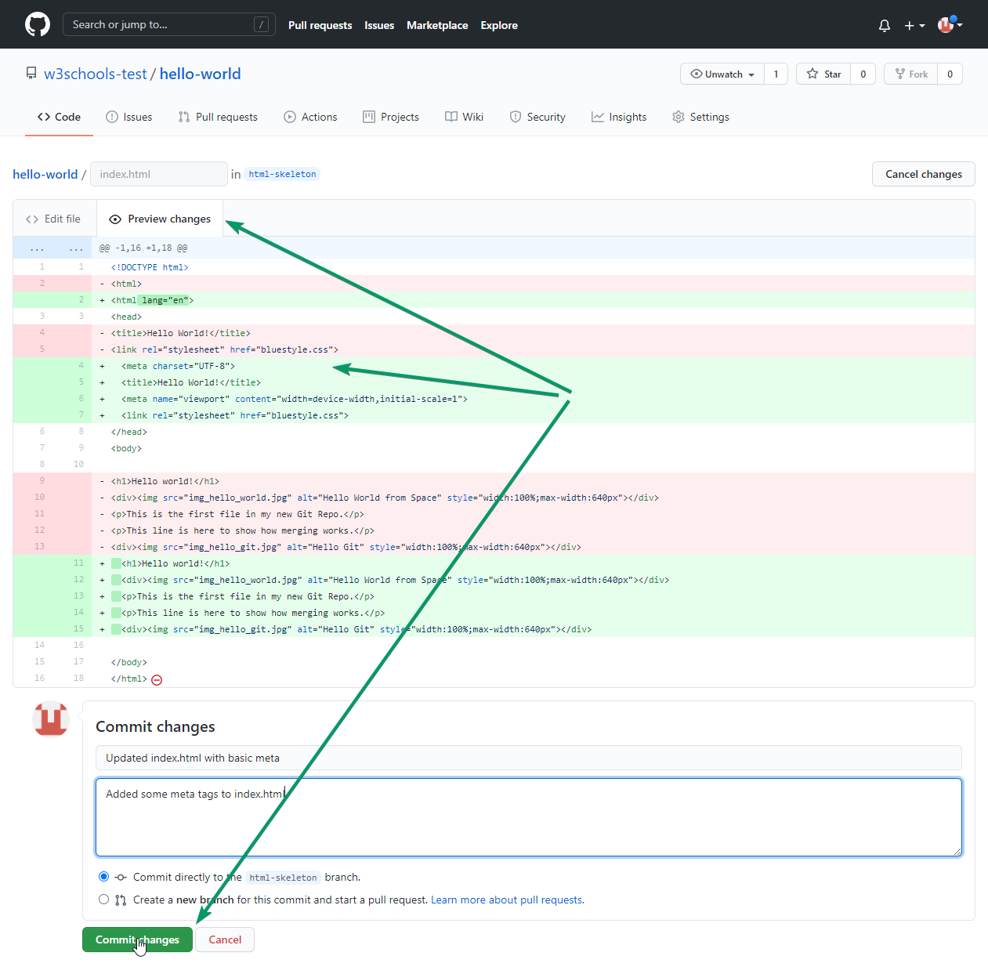

If you are happy with the change, add a comment that explains what you did, and click Commit changes.

You now have a new branch on GitHub, updated with some changes!

## Create a New Branch on GitHub

On GitHub, access your repository and click the "master" branch button.

There you can create a new Branch. Type in a descriptive name, and click Create branch:



The branch should now be created and active. You can confirm which branch you are working on by looking at the branch button. See that it now says "html-skeleton" instead of "main"?



Start working on an existing file in this branch. Click the "index.html" file and start editing:



After you have finished editing the file, you can click the "Preview changes" tab to see the changes you made highlighted:



If you are happy with the change, add a comment that explains what you did, and click Commit changes.

You now have a new branch on GitHub, updated with some changes!

## Push a Branch to GitHub

Let's try to create a new local branch, and push that to GitHub.

Start by creating a branch, like we did earlier:

### Example

git checkout -b update-readme

Switched to a new branch 'update-readme'

And we make some changes to the README.md file. Just add a new line.

So now we check the status of the current branch.

### Example

git status

On branch update-readme

Changes not staged for commit:

(use "git add ..." to update what will be committed)

(use "git restore ..." to discard changes in working directory)

modified: README.md

no changes added to commit (use "git add" and/or "git commit -a")

We see that README.md is modified but not added to the Staging Environment:

### Example

git add README.md

Check the status of the branch:

### Example

git status

On branch update-readme

Changes to be committed:

(use "git restore --staged ..." to unstage)

modified: README.md

We are happy with our changes. So we will commit them to the branch:

### Example

git commit -m "Updated readme for GitHub Branches"

[update-readme 836e5bf] Updated readme for GitHub Branches

1 file changed, 1 insertion(+)

Now push the branch from our local Git repository, to GitHub, where everyone can see the changes:

### Example

git push origin update-readme

Enumerating objects: 5, done.

Counting objects: 100% (5/5), done.

Delta compression using up to 16 threads

Compressing objects: 100% (3/3), done.

Writing objects: 100% (3/3), 366 bytes | 366.00 KiB/s, done.

Total 3 (delta 2), reused 0 (delta 0), pack-reused 0

remote: Resolving deltas: 100% (2/2), completed with 2 local objects.

remote:

remote: Create a pull request for 'update-readme' on GitHub by visiting:

remote: https://github.com/w3schools-test/hello-world/pull/new/update-readme

remote:

To https://github.com/w3schools-test/hello-world.git

* [new branch] update-readme -> update-readme

Go to GitHub, and confirm that the repository has a new branch:

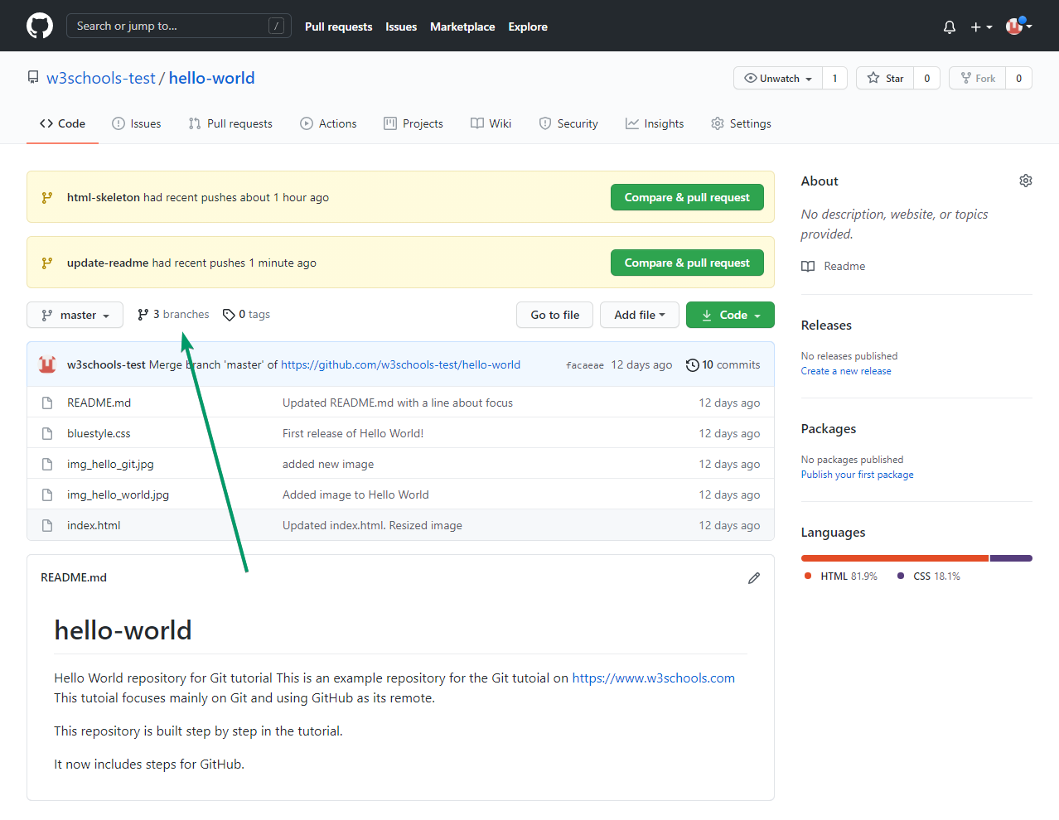

In GitHub, we can now see the changes and merge them into the master branch if we approve it.

If you click the "Compare & pull request", you can go through the changes made and new files added:

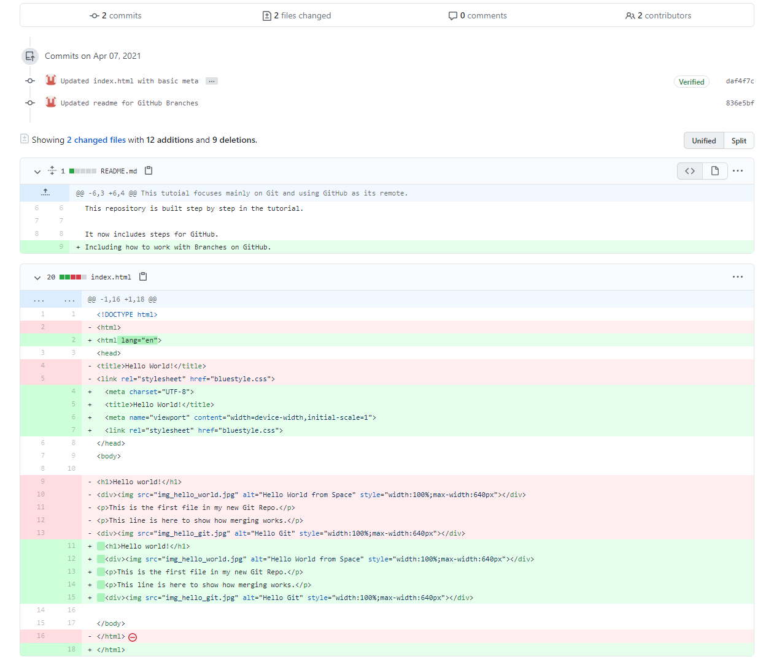

**Note:** This comparison shows both the changes from update-readme and html-skeleton because we created the new branch FROM html-skeleton.

If the changes look good, you can go forward, creating a pull request:

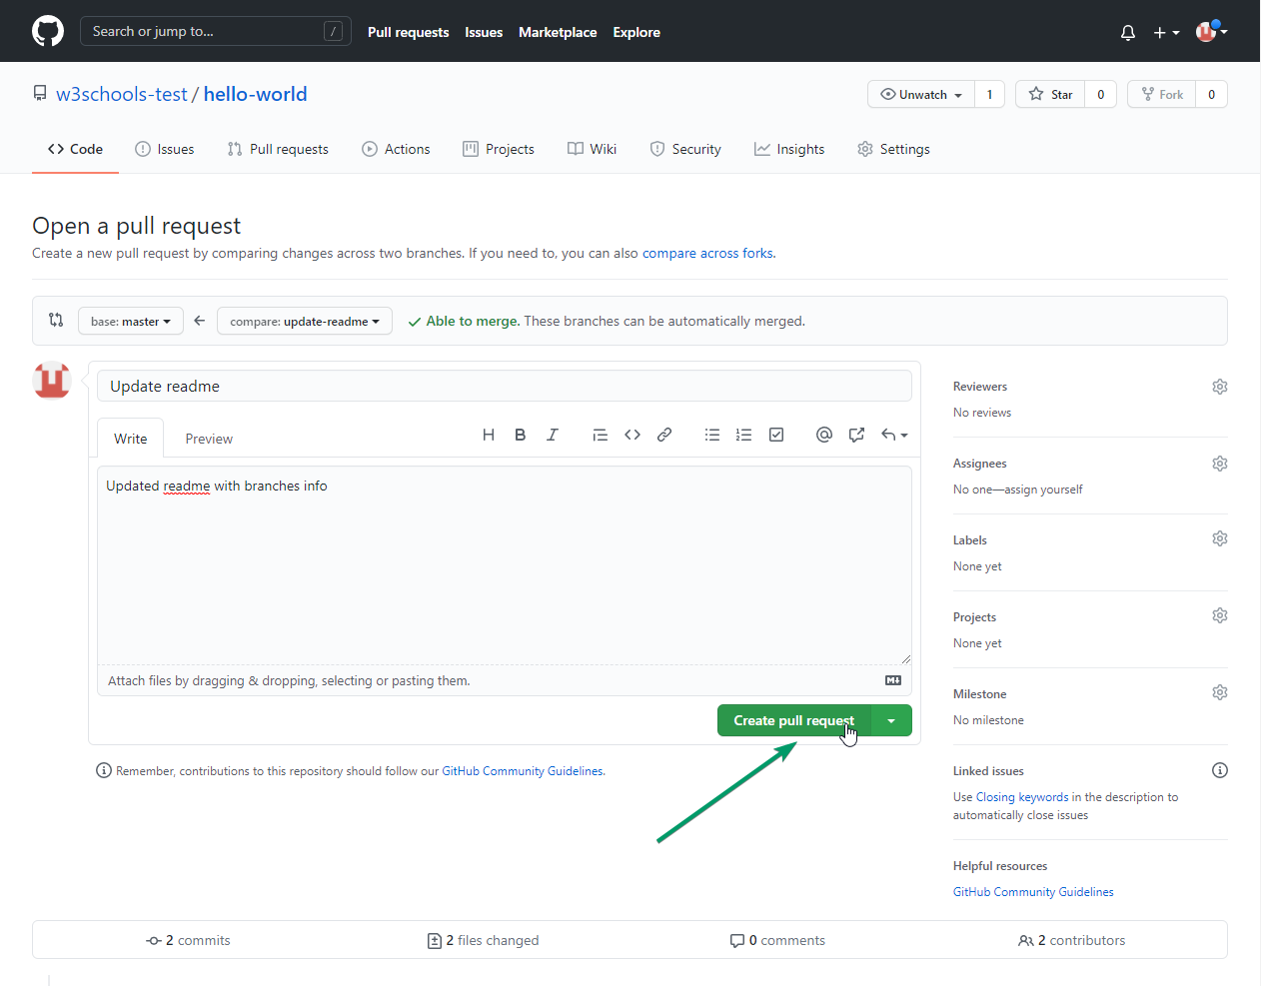

A pull request is how you propose changes. You can ask some to review your changes or pull your contribution and merge it into their branch.

Since this is your own repository, you can  merge your pull request yourself:

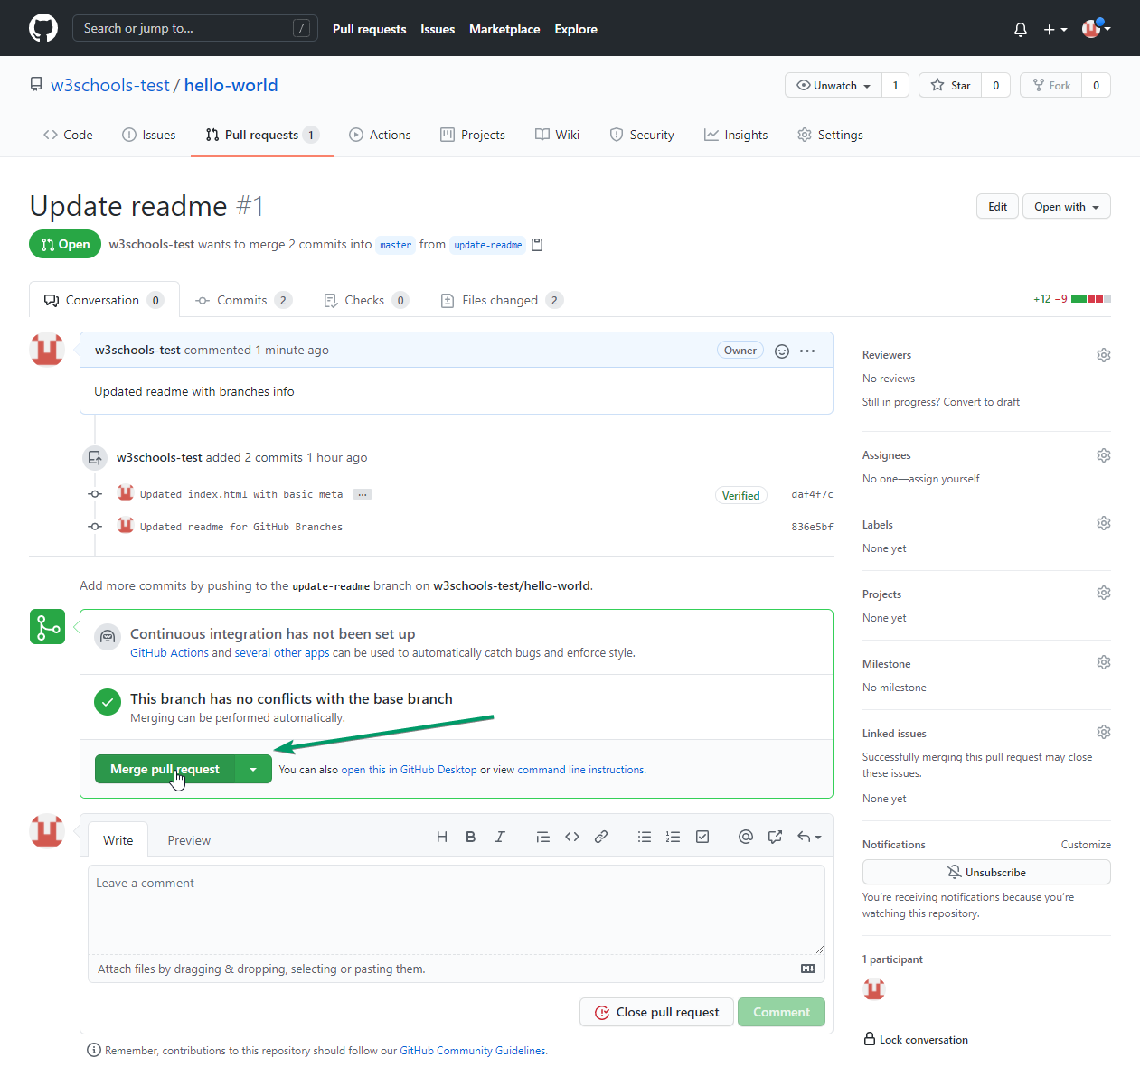

The pull request will record the changes, which means you can go through them later to figure out the changes made.

The result should be something like this:

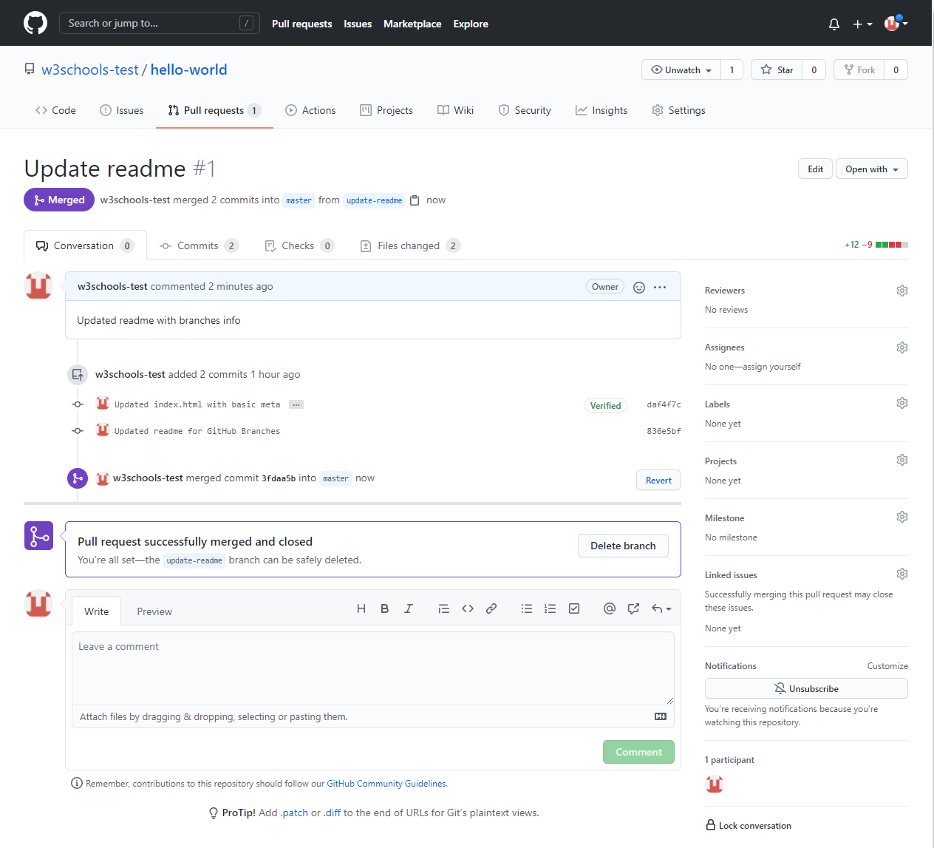

To keep the repo from getting overly complicated, you can delete the now unused branch by clicking "Delete branch".

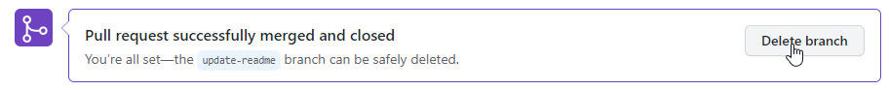

An after you confirm that the changes from the previous branch were included, delete that as well:

## Working using the GitHub Flow

On this page, you will learn how to get the best out of working with GitHub.

The GitHub flow is a workflow designed to work well with Git and GitHub.

It focuses on branching and makes it possible for teams to experiment freely, and make deployments regularly.

The GitHub flow works like this:

* Create a new Branch
* Make changes and add Commits
* Open a Pull Request
* Review
* Deploy
* Merge

You should already have a good understanding of how this works from the previous chapters. This chapter focuses on understanding how the flow makes it easy for you to work together.

## Create a New Branch

Branching is the key concept in Git. And it works around the rule that the master branch is ALWAYS deployable.

That means, if you want to try something new or experiment, you create a new branch! Branching gives you an environment where you can make changes without affecting the main branch.

When your new branch is ready, it can be reviewed, discussed, and merged with the main branch when ready.

When you make a new branch, you will (almost always) want to make it from the master branch.

**Note:** Keep in mind that you are working with others. Using descriptive names for new branches, so everyone can understand what is happening.

## Make Changes and Add Commits

After the new branch is created, it is time to get to work. Make changes by adding, editing and deleting files. Whenever you reach a small milestone, add the changes to your branch by commit.

Adding commits keeps track of your work. Each commit should have a message explaining what has changed and why. Each commit becomes a part of the history of the branch, and a point you can revert back to if you need to.

**Note:** commit messages are very important! Let everyone know what has changed and why. Messages and comments make it so much easier for yourself and other people to keep track of changes.

## Open a Pull Request

Pull requests are a key part of GitHub. A Pull Request notifies people you have changes ready for them to consider or review.

 You can ask others to review your changes or pull your contribution and merge it into their branch.

## Review

When a Pull Request is made, it can be reviewed by whoever has the proper access to the branch. This is where good discussions and review of the changes happen.

Pull Requests are designed to allow people to work together easily and produce better results together!

If you receive feedback and continue to improve your changes, you can push your changes with new commits, making further reviews possible.

**Note:** GitHub shows new commit and feedback in the "unified Pull Request view".

## Deploy

When the pull request has been reviewed and everything looks good, it is time for the final testing. GitHub allows you to deploy from a branch for final testing in production before merging with the master branch.

If any issues arise, you can undo the changes by deploying the master branch into production again!

**Note:** Teams often have dedicated testing environments used for deploying branches.

## Merge

After exhaustive testing, you can merge the code into the master branch!

Pull Requests keep records of changes to your code, and if you commented and named changes well, you can go back and understand why changes and decisions were made.

**Note:** You can add keywords to your pull request for easier searching!

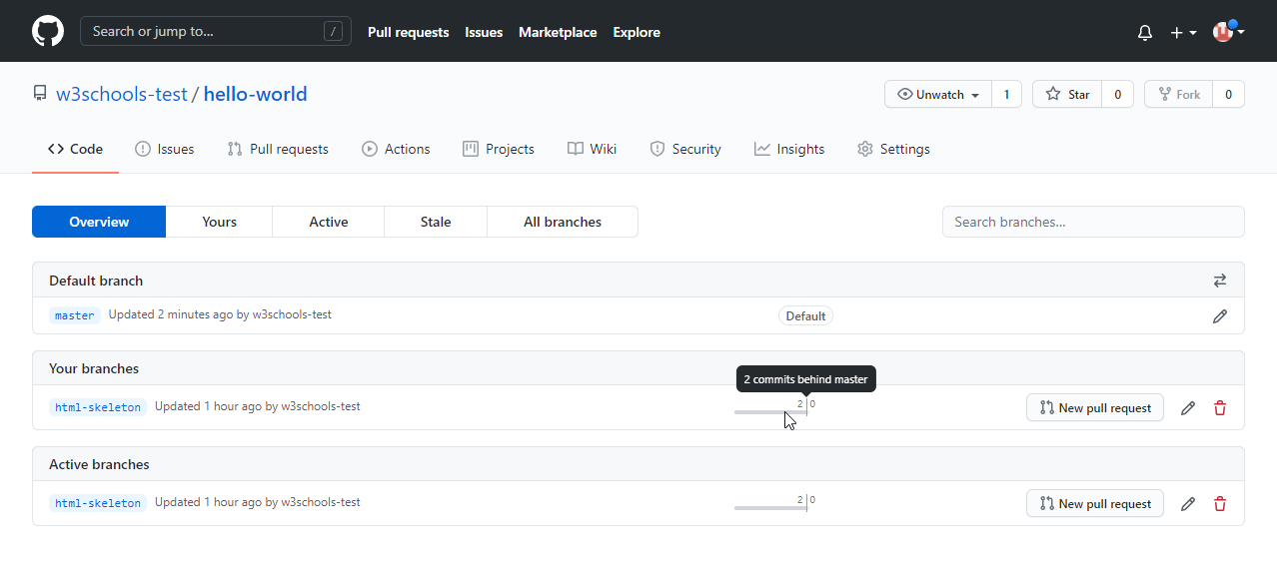

## Host Your Page on GitHub

With GitHub pages, GitHub allows you to host a webpage from your repository. Let's try to use GitHub Pages to host our repository.

## Create a New Repository

Start by signing in to GitHub. GitHub pages need a special name and setup to work, so we start by creating a new repository:

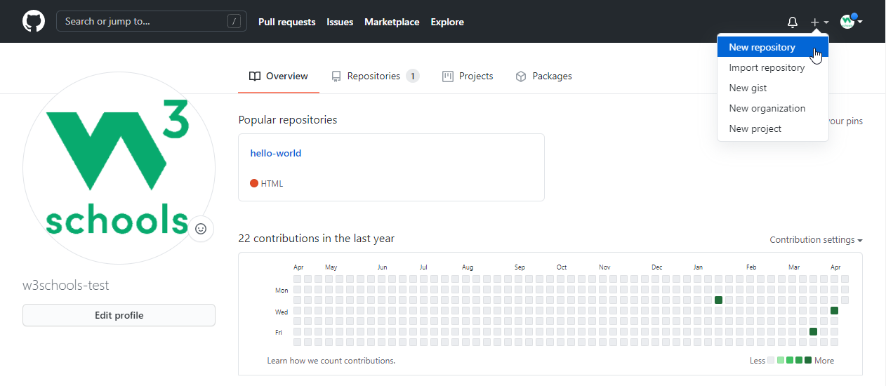

This repository needs a special name to function as a GitHub page. It needs to be your GitHub username, followed by .github.io:

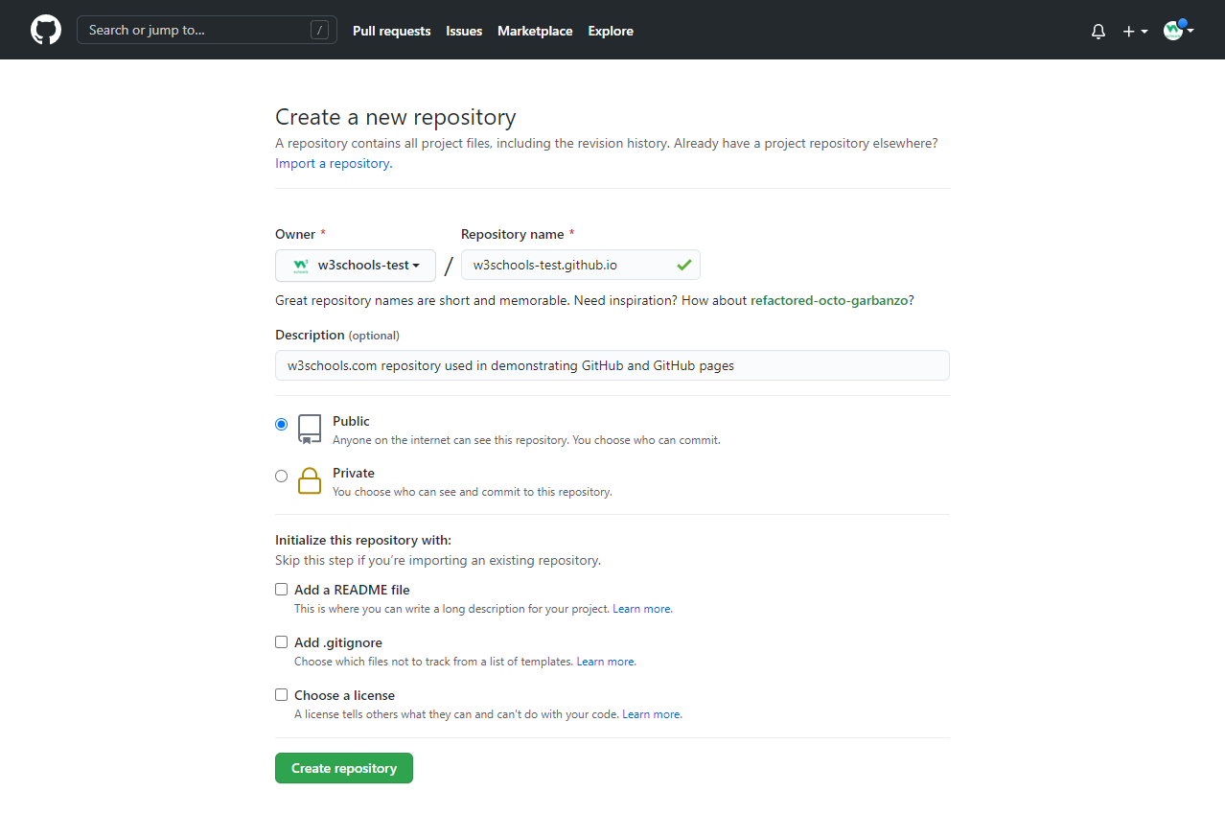

## Push Local Repository to GitHub Pages

We add this new repository as a remote for our local repository, we are calling it gh-page (for GitHub Pages).

Copy the URL from here:

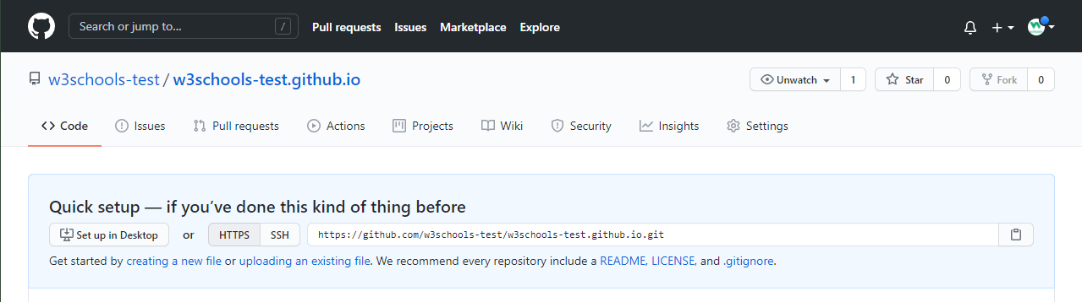

And add it as a new remote:

### Example

git remote add gh-page https://github.com/w3schools-test/w3schools-test.github.io.git

Make sure you are on the master branch, then push the master branch to the new remote:

### Example

git push gh-page master

Enumerating objects: 33, done.

Counting objects: 100% (33/33), done.

Delta compression using up to 16 threads

Compressing objects: 100% (33/33), done.

Writing objects: 100% (33/33), 94.79 KiB | 15.80 MiB/s, done.

Total 33 (delta 18), reused 0 (delta 0), pack-reused 0

remote: Resolving deltas: 100% (18/18), done.

To https://github.com/w3schools-test/w3schools-test.github.io.git

* [new branch] master -> master

**Note:** If this is the first time you are connecting to GitHub, you will get some kind of notification to authenticate this connection.

Check that the new repository has received all the files:

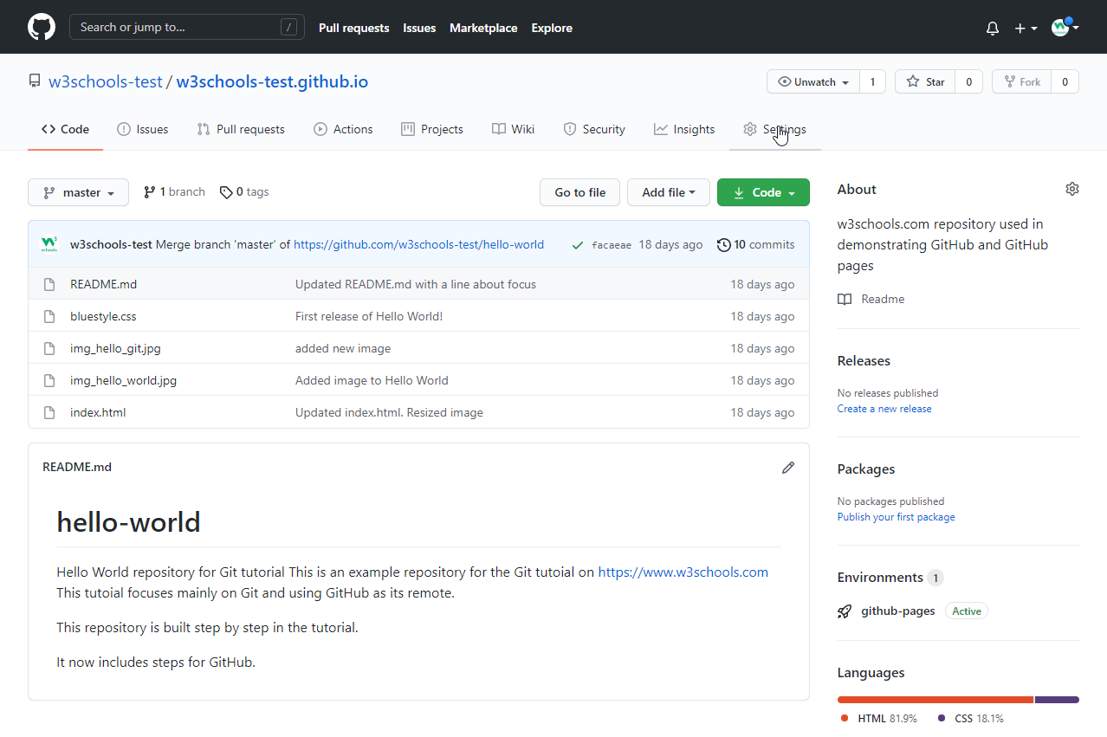

## Check Out Your Own GitHub Page

That looks good, now click the Settings menu and navigate to the Pages tab:

## Add to Someone Else's Repository

At the heart of Git is collaboration. However, Git does not allow you to add code to someone else's repository without access rights.

In these next 3 chapters we will show you how to copy a repository, make changes to it, and suggest those changes be implemented to the original repository.

At the end of these chapters, you will have the opportunity to add a message to our public GitHub page: https://w3schools-test.github.io/

## Fork a Repository

A fork is a copy of a repository. This is useful when you want to contribute to someone else's project or start your own project based on theirs.

fork is not a command in Git, but something offered in GitHub and other repository hosts. Let's start by logging in to GitHub, and fork our repository:  
https://github.com/w3schools-test/w3schools-test.github.io

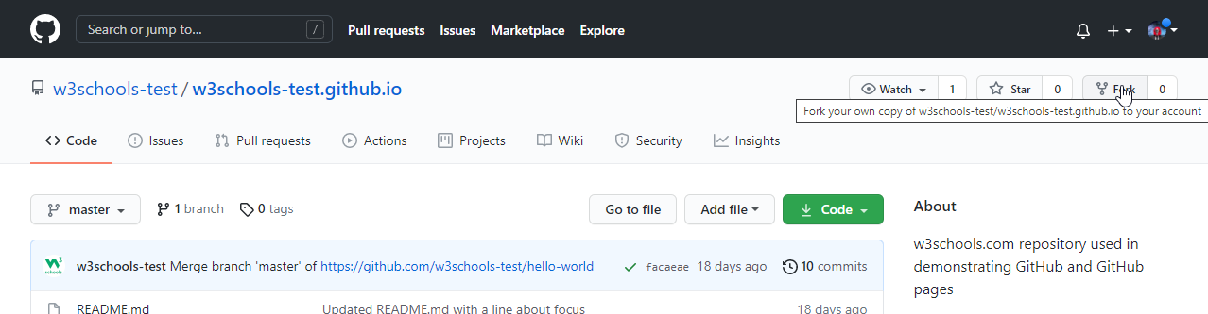

Now we have our own copy of w3schools-test.github.io:

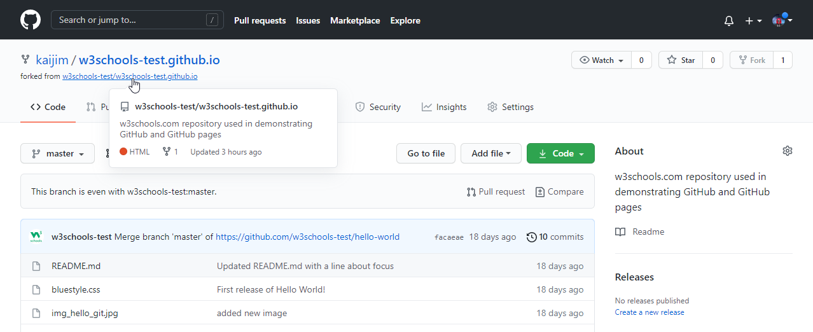

Now let's look at how we add a local copy of this for us to work with.

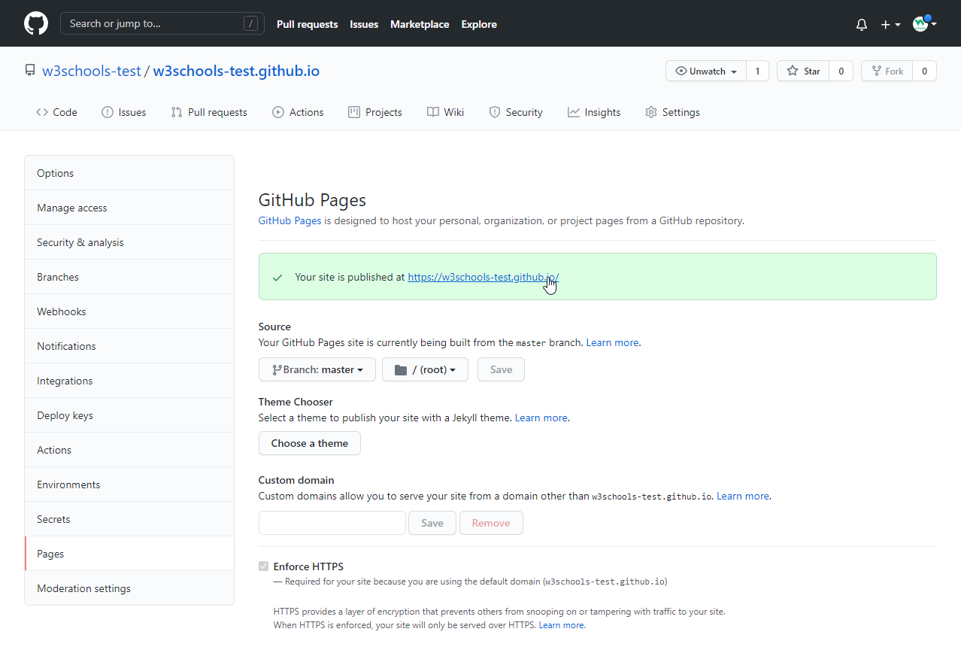

## The GitHub page is created, and you can click the URL to view the result! Add to Someone Else's Repository

At the heart of Git is collaboration. However, Git does not allow you to add code to someone else's repository without access rights.

In these next 3 chapters we will show you how to copy a repository, make changes to it, and suggest those changes be implemented to the original repository.

At the end of these chapters, you will have the opportunity to add a message to our public GitHub page: https://w3schools-test.github.io/

## Fork a Repository

A fork is a copy of a repository. This is useful when you want to contribute to someone else's project or start your own project based on theirs.

fork is not a command in Git, but something offered in GitHub and other repository hosts. Let's start by logging in to GitHub, and fork our repository:  
https://github.com/w3schools-test/w3schools-test.github.io



Now we have our own copy of w3schools-test.github.io:



Now let's look at how we add a local copy of this for us to work with.

# **Git Clone from GitHub**

## Clone a Fork from GitHub

Now we have our own fork, but only on GitHub. We also want a clone on our local Git to keep working on it.

A clone is a full copy of a repository, including all logging and versions of files.

Move back to the **original** repository, and click the green "Code" button to get the URL to clone:

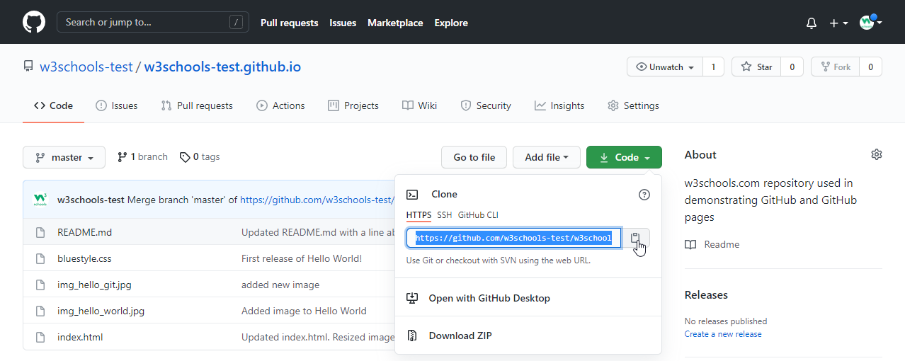

Open your Git bash and clone the repository:

### Example

git clone https://github.com/w3schools-test/w3schools-test.github.io.git

Cloning into 'w3schools-test.github.io'...

remote: Enumerating objects: 33, done.

remote: Counting objects: 100% (33/33), done.

remote: Compressing objects: 100% (15/15), done.

remote: Total 33 (delta 18), reused 33 (delta 18), pack-reused 0

Receiving objects: 100% (33/33), 94.79 KiB | 3.16 MiB/s, done.

Resolving deltas: 100% (18/18), done.

Take a look in your file system, and you will see a new directory named after the cloned project:

### Example

ls

w3schools-test.github.io/

**Note:** To specify a specific folder to clone to, add the name of the folder after the repository URL, like this: git clone https://github.com/w3schools-test/w3schools-test.github.io.git myfolder

Navigate to the new directory, and check the status:

### Example

cd w3schools-test.github.io

git status

On branch master

Your branch is up to date with 'origin/master'.

nothing to commit, working tree clean

And check the log to confirm that we have the full repository data:

### Example

git log

commit facaeae8fd87dcb63629f108f401aa9c3614d4e6 (HEAD -> master, origin/master, origin/HEAD)

Merge: e7de78f 5a04b6f

Author: w3schools-test

Date: Fri Mar 26 15:44:10 2021 +0100

Merge branch 'master' of https://github.com/w3schools-test/hello-world

commit e7de78fdefdda51f6f961829fcbdf197e9b926b6

Author: w3schools-test

Date: Fri Mar 26 15:37:22 2021 +0100

Updated index.html. Resized image

.....

Now we have a full copy of the original repository.

## Configuring Remotes

Basically, we have a full copy of a repository, whose origin we are not allowed to make changes to.

Let's see how the remotes of this Git is set up:

### Example

git remote -v

origin https://github.com/w3schools-test/w3schools-test.github.io.git (fetch)

origin https://github.com/w3schools-test/w3schools-test.github.io.git (push)

We see that origin is set up to the original "w3schools-test" repository, we also want to add our own fork.

First, we rename the original origin remote:

### Example

git remote rename origin upstream

git remote -v

upstream https://github.com/w3schools-test/w3schools-test.github.io.git (fetch)

upstream https://github.com/w3schools-test/w3schools-test.github.io.git (push)

Then fetch the URL of our own fork:

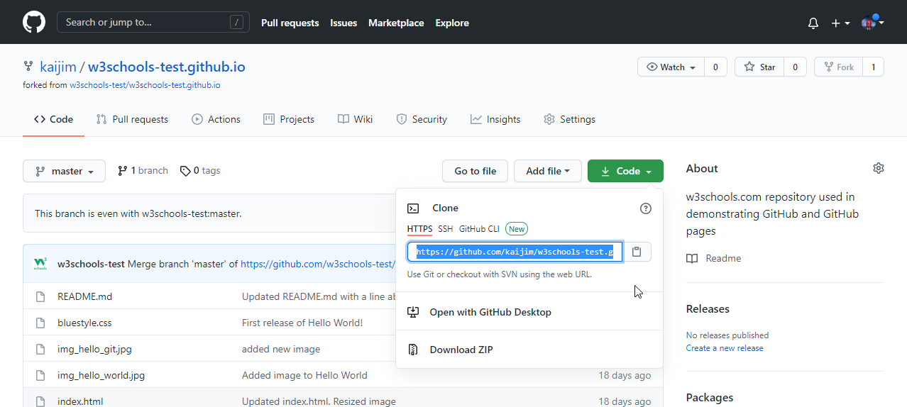

And add that as origin:

### Example

git remote add origin https://github.com/kaijim/w3schools-test.github.io.git

git remote -v

origin https://github.com/kaijim/w3schools-test.github.io.git (fetch)

origin https://github.com/kaijim/w3schools-test.github.io.git (push)

upstream https://github.com/w3schools-test/w3schools-test.github.io.git (fetch)

upstream https://github.com/w3schools-test/w3schools-test.github.io.git (push)

**Note:** According to Git naming conventions, it is recommended to name your own repository origin, and the one you forked for upstream

Now we have 2 remotes:

* origin - our own fork, where we have read and write access
* upstream - the original, where we have read-only access

Now we are going to make some changes to the code. In the next chapter, we will cover how we suggest those changes to the original repository.

# **Git GitHub Send Pull Request**

## Push Changes to Our GitHub Fork

We have made a lot of changes to our local Git.

Now we push them to our GitHub fork:

commit the changes:

### Example

git push origin

Enumerating objects: 8, done.

Counting objects: 100% (8/8), done.

Delta compression using up to 16 threads

Compressing objects: 100% (5/5), done.

Writing objects: 100% (5/5), 393.96 KiB | 32.83 MiB/s, done.

Total 5 (delta 0), reused 0 (delta 0), pack-reused 0

To https://github.com/kaijim/w3schools-test.github.io.git

facaeae..ebb1a5c master -> master

Go to GitHub, and we see that the repository has a new commit. And we can send a Pull Request to the original repository:

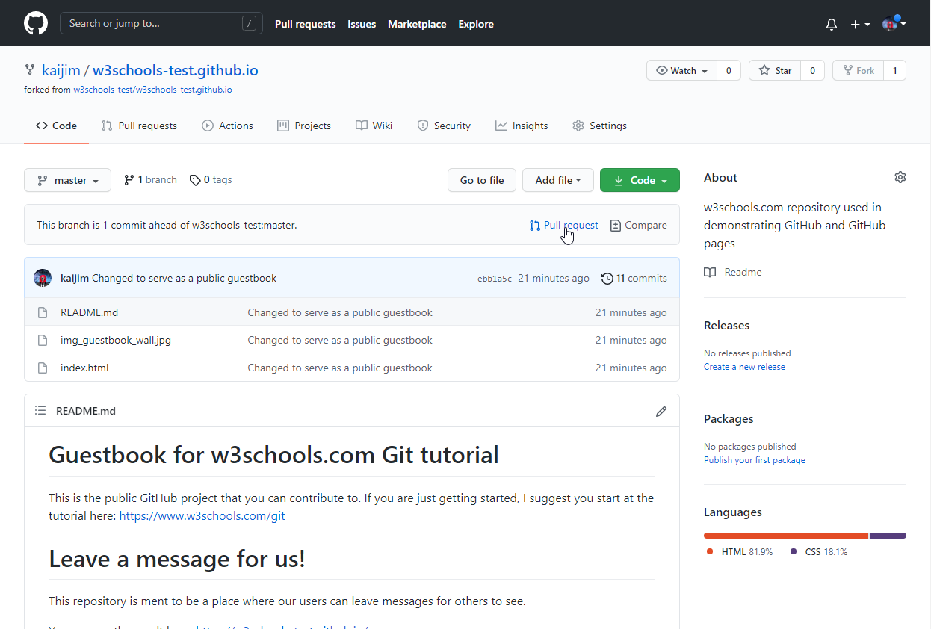

Click that and create a pull request:

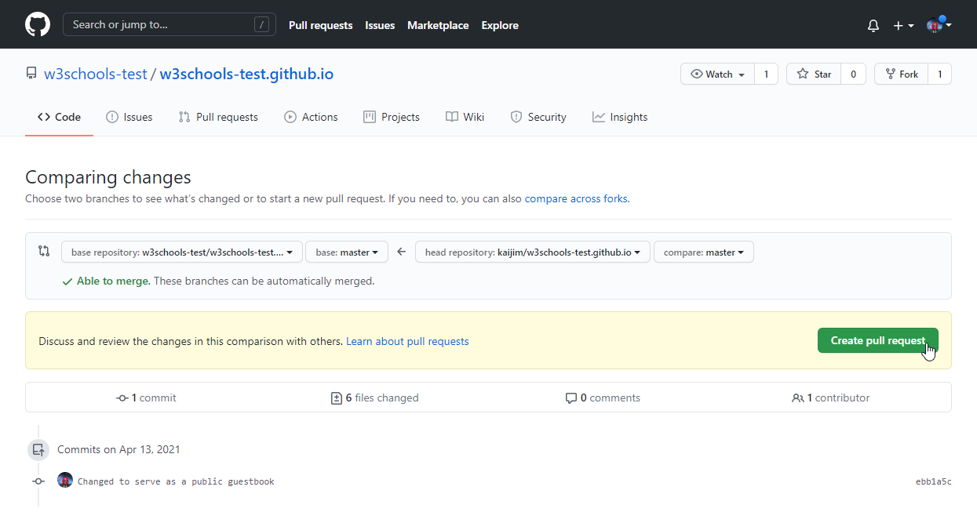

Remember to add an explanation for the administrators.

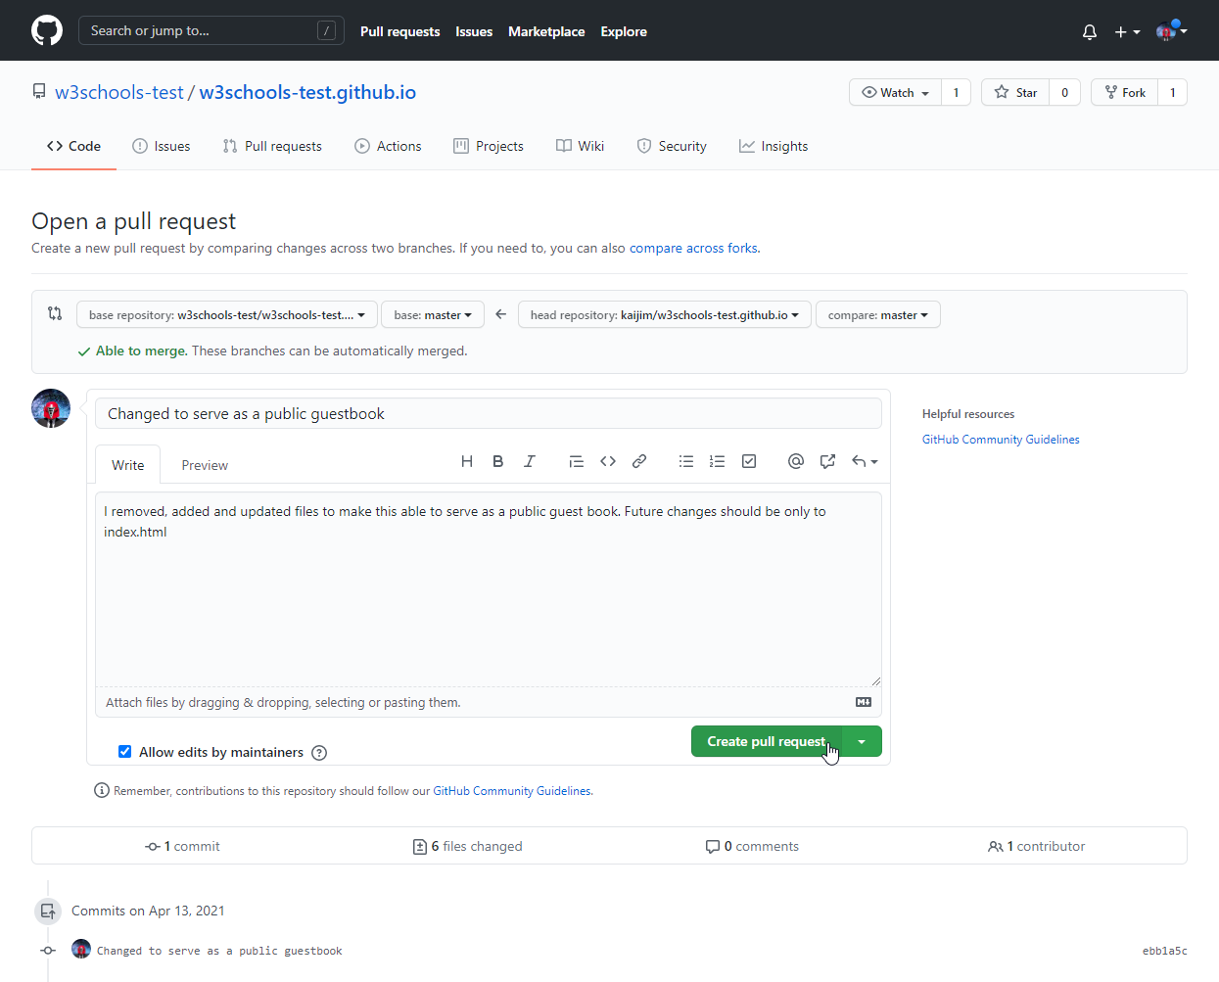

Pull Request is sent:

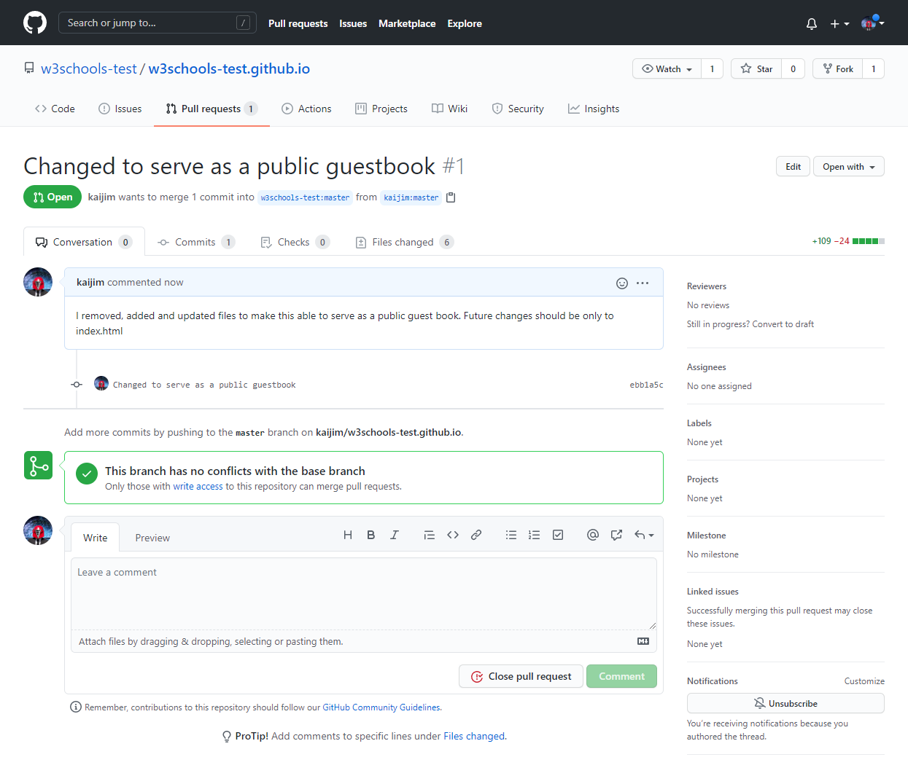

## Approving Pull Requests

Now any member with access can see the Pull Request when they see the original repository:

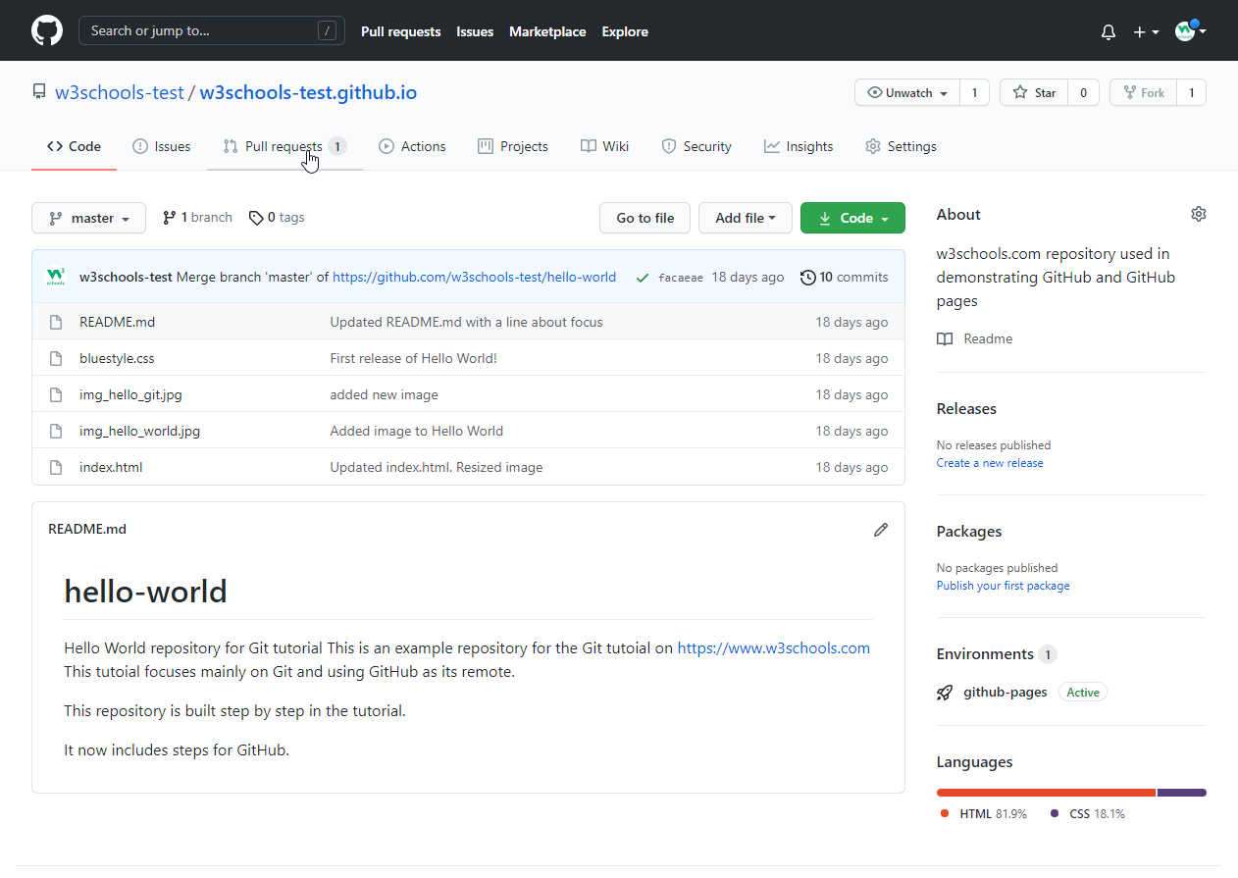

And they can see the proposed changes:

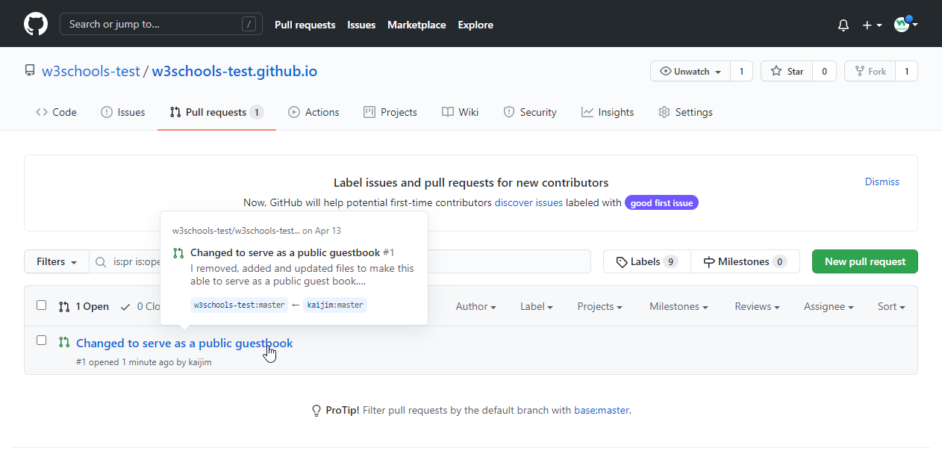

Comment on the changes and merge:

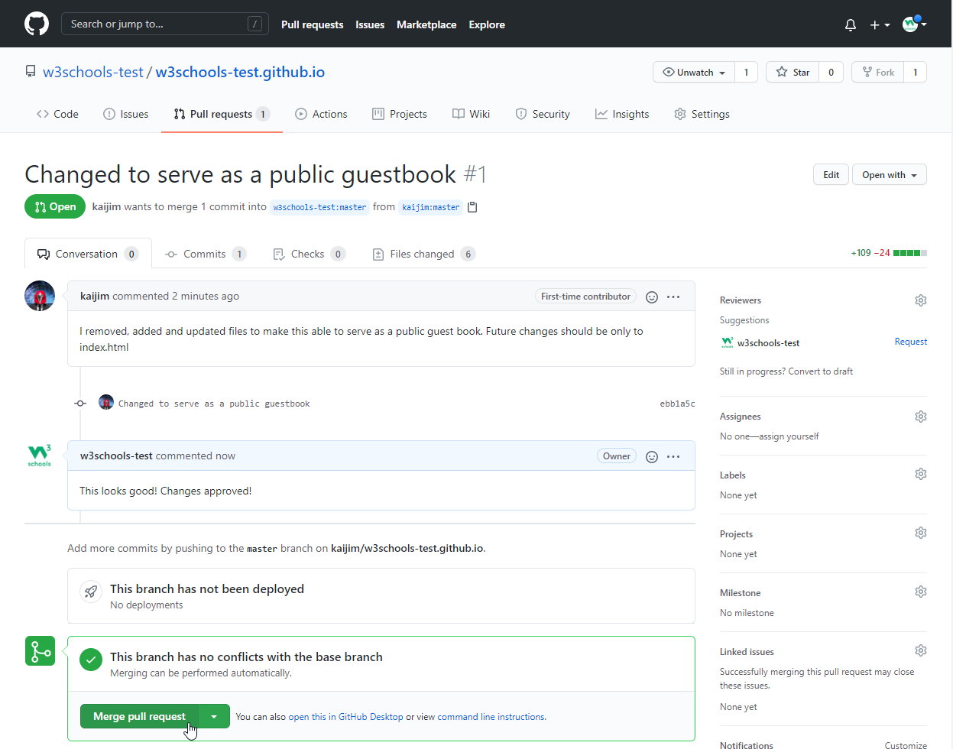

Confirm:

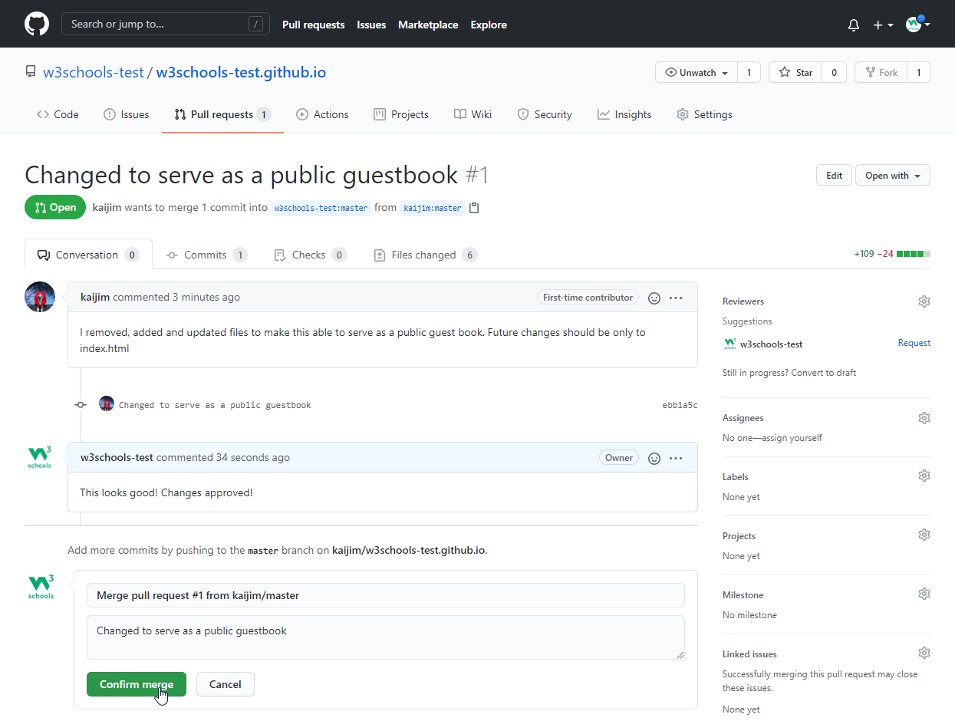

And changes have been merged with master:

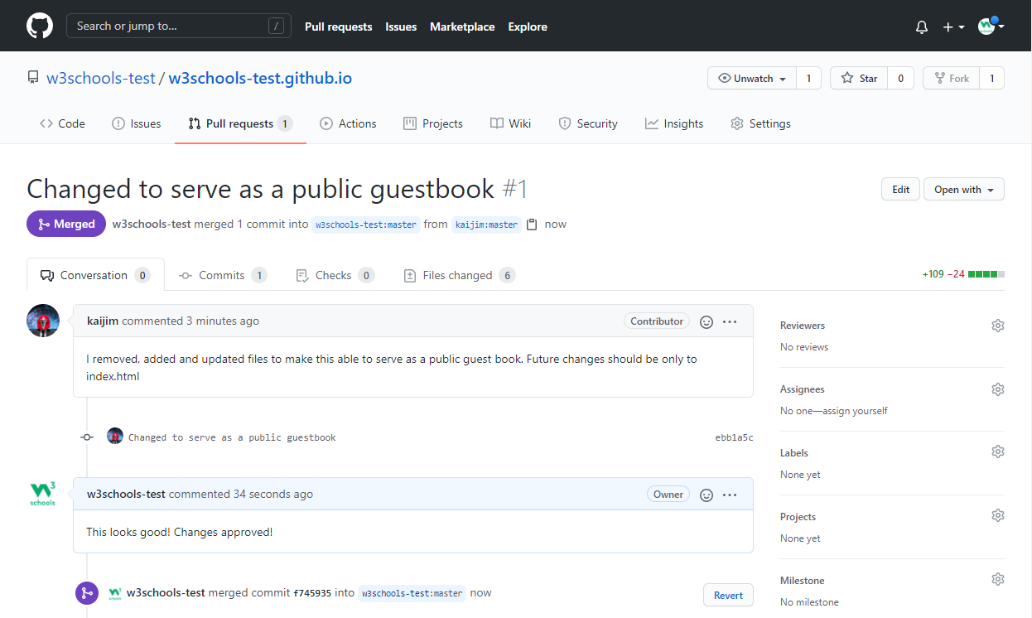

Now you try!

# **Git Ignore and .gitignore**

## Git Ignore

When sharing your code with others, there are often files or parts of your project, you do not want to share.

Examples

* log files
* temporary files
* hidden files
* personal files
* etc.

Git can specify which files or parts of your project should be ignored by Git using a .gitignore file.

Git will not track files and folders specified in .gitignore. However, the .gitignore file itself **IS** tracked by Git.

## Create .gitignore

To create a .gitignore file, go to the root of your local Git, and create it:

### Example

touch .gitignore

Now open the file using a text editor.

We are just going to add two simple rules:

* Ignore any files with the .log extension
* Ignore everything in any directory named temp

### Example

# ignore ALL .log files  
*.log  
  
# ignore ALL files in ANY directory named temp  
temp/

Now all .log files and anything in temp folders will be ignored by Git.

**Note:** In this case, we use a single .gitignore which applies to the entire repository.

It is also possible to have additional .gitignore files in subdirectories. These only apply to files or folders within that directory.

## Rules for .gitignore

Here are the general rules for matching patterns in .gitignore files:

|  |  |  |
| --- | --- | --- |
| **Pattern** | **Explanation/Matches** | **Examples** |
|  | Blank lines are ignored |  |
| # text comment | Lines starting with # are ignored |  |
| name | All name files, name folders, and files and folders in any name folder | /name.log /name/file.txt /lib/name.log |
| name/ | Ending with / specifies the pattern is for a folder. Matches all files and folders in any name folder | /name/file.txt /name/log/name.log  **no match:** /name.log |
| name.file | All files with the name.file | /name.file /lib/name.file |
| /name.file | Starting with / specifies the pattern matches only files in the root folder | /name.file  **no match:** /lib/name.file |
| lib/name.file | Patterns specifiing files in specific folders are always realative to root (even if you do not start with / ) | /lib/name.file  **no match:** name.file /test/lib/name.file |
| **/lib/name.file | Starting with ** before / specifies that it matches any folder in the repository. Not just on root. | /lib/name.file /test/lib/name.file |
| **/name | All name folders, and files and folders in any name folder | /name/log.file /lib/name/log.file /name/lib/log.file |
| /lib/**/name | All name folders, and files and folders in any name folder within the lib folder. | /lib/name/log.file /lib/test/name/log.file /lib/test/ver1/name/log.file  **no match:** /name/log.file |
| *.file | All files withe .file extention | /name.file /lib/name.file |
| *name/ | All folders ending with name | /lastname/log.file /firstname/log.file |
| name?.file | ? matches a **single** non-specific character | /names.file /name1.file  **no match:** /names1.file |
| name[a-z].file | [range] matches a **single** character in the specified range (in this case a character in the range of a-z, and also be numberic.) | /names.file /nameb.file  **no match:** /name1.file |
| name[abc].file | [set] matches a **single** character in the specified set of characters (in this case either a, b, or c) | /namea.file /nameb.file  **no match:** /names.file |
| name[!abc].file | [!set] matches a **single** character, **except** the ones spesified in the set of characters (in this case a, b, or c) | /names.file /namex.file  **no match:** /namesb.file |
| *.file | All files withe .file extention | /name.file /lib/name.file |
| name/ !name/secret.log | ! specifies a negation or exception. Matches all files and folders in any name folder, except name/secret.log | /name/file.txt /name/log/name.log  **no match:** /name/secret.log |
| *.file!name.file | ! specifies a negation or exception. All files withe .file extention, except name.file | /log.file /lastname.file  **no match:** /name.file |
| *.file!name/*.file junk.* | Adding new patterns after a negation will re-ignore a previous negated file All files withe .file extention, except the ones in name folder. Unless the file name is junk | /log.file /name/log.file  **no match:** /name/junk.file |

## Local and Personal Git Ignore Rules

It is also possible to ignore files or folders but not show it in the distributed .gitignore file.

These kinds of ignores are specified in the .git/info/exclude file. It works the same way as .gitignore but are not shown to anyone else.

# **Git Security SSH**

## Git Security

Up to this point, we have used HTTPS to connect to our remote repository.

HTTPS will usually work just fine, but you should use SSH if you work with unsecured networks. And sometimes, a project will require that you use SSH.

## What is SSH

SSH is a secure shell network protocol that is used for network management, remote file transfer, and remote system access.

SSH uses a pair of SSH keys to establish an authenticated and encrypted secure network protocol. It allows for secure remote communication on unsecured open networks.

SSH keys are used to initiate a secure "handshake". When generating a set of keys, you will generate a "public" and "private" key.

The "public" key is the one you share with the remote party. Think of this more as the lock.

The "private" key is the one you keep for yourself in a secure place. Think of this as the key to the lock.

SSH keys are generated through a security algorithm. It is all very complicated, but it uses prime numbers, and large random numbers to make the public and private key.

It is created so that the public key can be derived from the private key, but not the other way around.

## Generating an SSH Key Pair

In the command line for Linux, Apple, and in the Git Bash for Windows, you can generate an SSH key.

Let's go through it, step by step.

Start by creating a new key, using your email as a label:

### Example

ssh-keygen -t rsa -b 4096 -C "test@w3schools.com"

Generating public/private rsa key pair.

Enter file in which to save the key (/Users/user/.ssh/id_rsa):

Created directory '/Users/user/.ssh'.

Enter passphrase (empty for no passphrase):

Enter same passphrase again:

Your identification has been saved in /Users/user/.ssh/id_rsa

Your public key has been saved in /Users/user/.ssh/id_rsa.pub

The key fingerprint is:

SHA256:******************************************* test@w3schools.com

The key's randomart image is:

+---[RSA 4096]----+

| |

| |

| |

| |

| |

| |

| |

| |

| |

+----[SHA256]-----+

You will be prompted with the following through this creation:

Enter file in which to save the key (/c/Users/user/.ssh/id_rsa):

Select a file location, or press "Enter" to use the default file location.

Enter passphrase (empty for no passphrase):

Enter same passphrase again:

Entering a secure passphrase will create an additional layer of security. Preventing anyone who gains access to the computer to use that key without the passphrase. However, it will require you to supply the passphrase anytime the SSH key is used.

Now we add this SSH key pair to the SSH-Agent (using the file location from above):

### Example

ssh-add /Users/user/.ssh/id_rsa

Enter passphrase for /Users/user/.ssh/id_rsa:

Identity added: /Users/user/.ssh/id_rsa (test@w3schools.com)

You will be prompted to supply the passphrase, if you added one.

Now the SSH key pair is ready to use.

# **Git GitHub Add SSH**

## Copy the SSH Public Key

In the previous chapter, we created an SSH key pair.

Now we will use the clip < command to copy the public key to our clipboard:

### Example

clip < /Users/user/.ssh/id_rsa.pub

Go to GitHub, navigate to the top left corner, click your profile, and select: Settings:

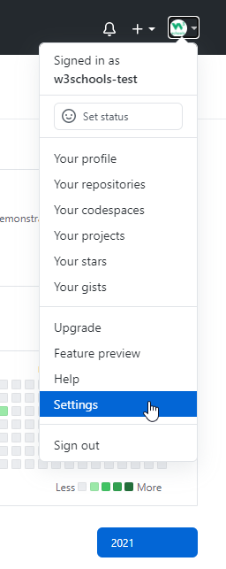

Then select "SSH and GPG keys". and click the "New SSH key" button:

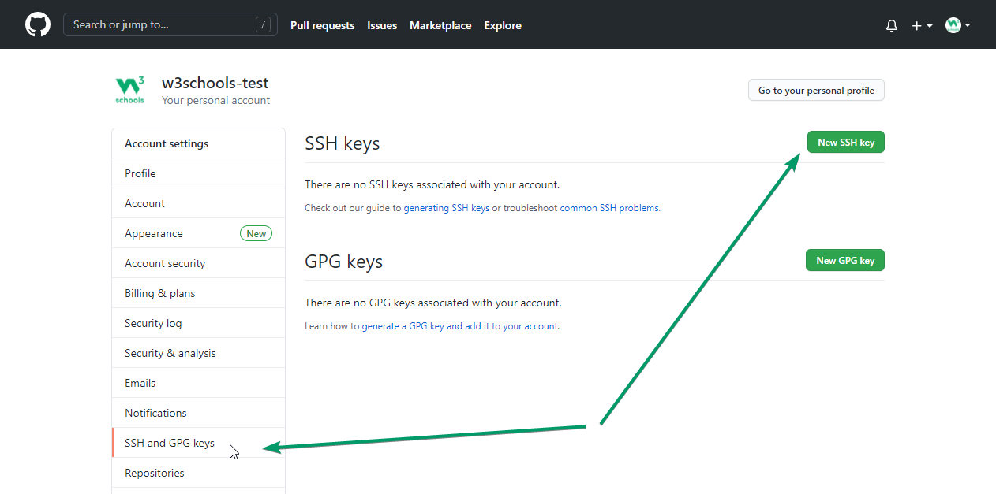

Select a title, and paste the public SSH key into the "Key" field, and click "Add SSH Key":

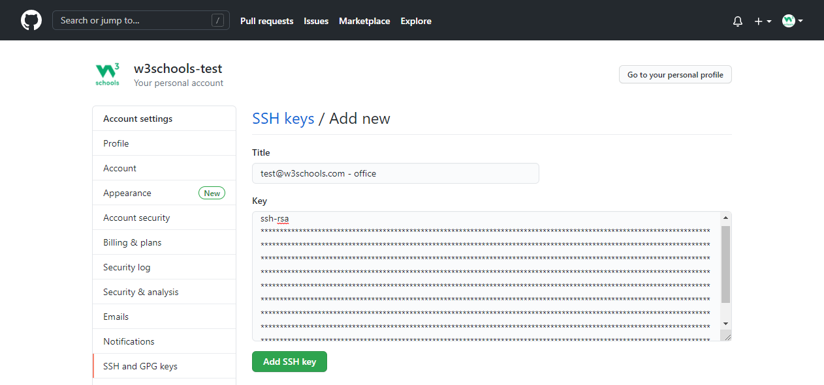

You will be prompted to supply your GitHub password.

You will see your new SSH key added:

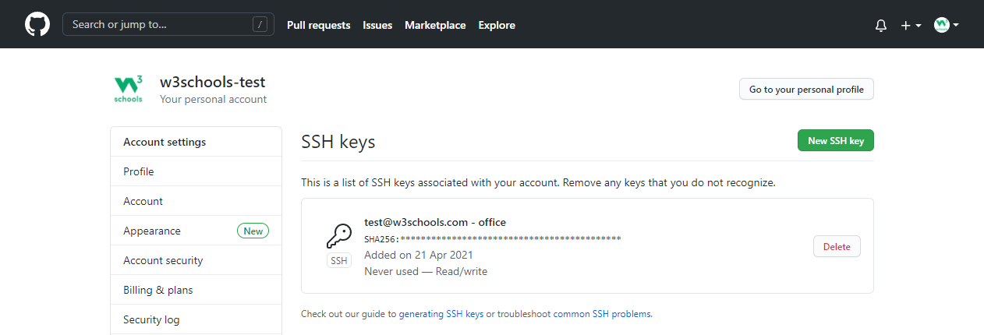

## Test SSH Connection to GitHub

Now we can test our connection via SSH to GitHub:

### Example

ssh -T git@github.com

The authenticity of host 'github.com (140.82.121.3)' can't be established.

RSA key fingerprint is SHA256:nThbg6kXUpJWGl7E1IGOCspRomTxdCARLviKw6E5SY8.

Are you sure you want to continue connecting (yes/no/[fingerprint])? yes

Warning: Permanently added 'github.com,140.82.121.3' (RSA) to the list of known hosts.

Hi w3schools-test! You've successfully authenticated, but GitHub does not provide shell access.

If the last line contains your username on GitHub, you are successfully authenticated!

## Add New GitHub SSH Remote

Now we can add a new remote via SSH to our Git.

First, get the SSH address from our repository on GitHub:

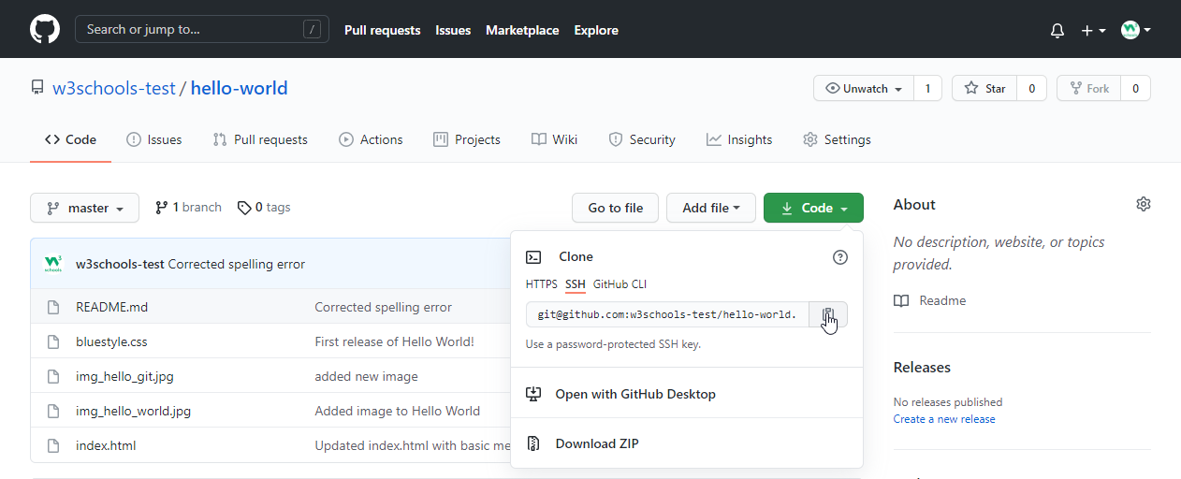

Then use that address to add a new origin:

### Example

git remote add ssh-origin git@github.com:w3schools-test/hello-world.git

**Note:** You can change a remote origin from HTTPS to SSH with the command: git remote set-url remote-name git@github.com:username/repository.git

### Example

git remote set-url origin git@github.com:w3schools-test/hello-world.git

## Git Revert

revert is the command we use when we want to take a previous commit and add it as a new commit, keeping the log intact.

Step 1: Find the previous commit:

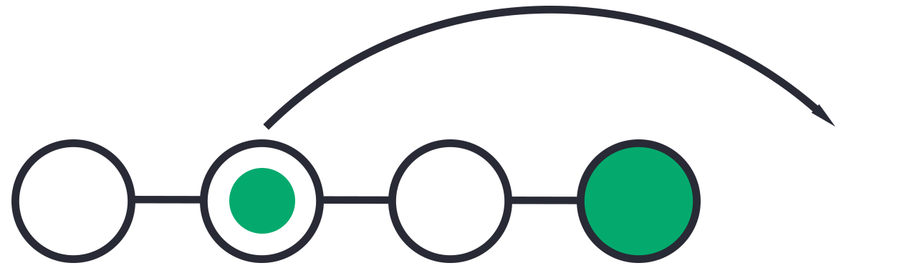

Step 2: Use it to make a new commit:



Let's make a new commit, where we have "accidentally" deleted a file:

### Example

git commit -m "Just a regular update, definitely no accidents here..."

[master 16a6f19] Just a regular update, definitely no accidents here...

1 file changed, 0 insertions(+), 0 deletions(-)

delete mode 100644 img_hello_git.jpg

Now we have a part in our commit history we want to go back to. Let's try and do that with revert.

## Git Revert Find Commit in Log

First thing, we need to find the point we want to return to. To do that, we need to go through the log.

To avoid the very long log list, we are going to use the --oneline option, which gives just one line per commit showing:

* The first seven characters of the commit hash
* the commit message

So let's find the point we want to revert:

### Example

git log --oneline

52418f7 (HEAD -> master) Just a regular update, definitely no accidents here...

9a9add8 (origin/master) Added .gitignore

81912ba Corrected spelling error

3fdaa5b Merge pull request #1 from w3schools-test/update-readme

836e5bf (origin/update-readme, update-readme) Updated readme for GitHub Branches

daf4f7c (origin/html-skeleton, html-skeleton) Updated index.html with basic meta

facaeae (gh-page/master) Merge branch 'master' of https://github.com/w3schools-test/hello-world

e7de78f Updated index.html. Resized image

5a04b6f Updated README.md with a line about focus

d29d69f Updated README.md with a line about GitHub

e0b6038 merged with hello-world-images after fixing conflicts

1f1584e added new image

dfa79db updated index.html with emergency fix

0312c55 Added image to Hello World

09f4acd Updated index.html with a new line

221ec6e First release of Hello World!

We want to revert to the previous commit: 52418f7 (HEAD -> master) Just a regular update, definitely no accidents here..., and we see that it is the latest commit.

ADVERTISEMENT

## Git Revert HEAD

We revert the latest commit using git revert HEAD (revert the latest change,  and then commit), adding the option --no-edit to skip the commit message editor (getting the default revert message):

### Example

git revert HEAD --no-edit

[master e56ba1f] Revert "Just a regular update, definitely no accidents here..."

Date: Thu Apr 22 10:50:13 2021 +0200

1 file changed, 0 insertions(+), 0 deletions(-)

create mode 100644 img_hello_git.jpg

Now let's check the log again:

### Example

git log --oneline

e56ba1f (HEAD -> master) Revert "Just a regular update, definitely no accidents here..."

52418f7 Just a regular update, definitely no accidents here...

9a9add8 (origin/master) Added .gitignore

81912ba Corrected spelling error

3fdaa5b Merge pull request #1 from w3schools-test/update-readme

836e5bf (origin/update-readme, update-readme) Updated readme for GitHub Branches

daf4f7c (origin/html-skeleton, html-skeleton) Updated index.html with basic meta

facaeae (gh-page/master) Merge branch 'master' of https://github.com/w3schools-test/hello-world

e7de78f Updated index.html. Resized image

5a04b6f Updated README.md with a line about focus

d29d69f Updated README.md with a line about GitHub

e0b6038 merged with hello-world-images after fixing conflicts

1f1584e added new image

dfa79db updated index.html with emergency fix

0312c55 Added image to Hello World

09f4acd Updated index.html with a new line

221ec6e First release of Hello World!

**Note:** To revert to earlier commits, use git revert HEAD~x (*x* being a number. 1 going back one more, 2 going back two more, etc.)

On the next page, we'll go over git reset, which brings the repository back to an earlier state in the commits without making a new commit.

## Git Reset

reset is the command we use when we want to move the repository back to a previous commit, discarding any changes made after that commit.

Step 1: Find the previous commit:

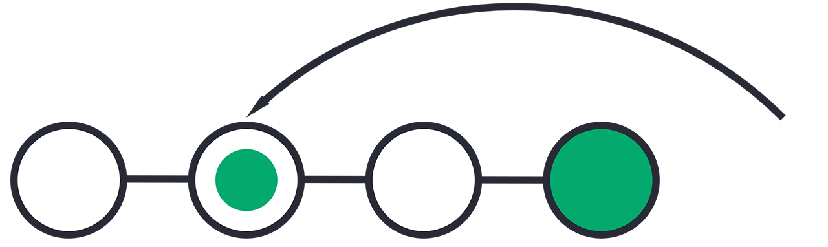

Step 2: Move the repository back to that step:



After the previous chapter, we have a part in our commit history we could go back to. Let's try and do that with reset.

## Git Reset Find Commit in Log

First thing, we need to find the point we want to return to. To do that, we need to go through the log.

To avoid the very long log list, we are going to use the --oneline option, which gives just one line per commit showing:

* The first seven characters of the commit hash - this is what we need to refer to in our reset command.
* the commit message

So let's find the point we want to reset to:

### Example

git log --oneline

e56ba1f (HEAD -> master) Revert "Just a regular update, definitely no accidents here..."

52418f7 Just a regular update, definitely no accidents here...

9a9add8 (origin/master) Added .gitignore

81912ba Corrected spelling error

3fdaa5b Merge pull request #1 from w3schools-test/update-readme

836e5bf (origin/update-readme, update-readme) Updated readme for GitHub Branches

daf4f7c (origin/html-skeleton, html-skeleton) Updated index.html with basic meta

facaeae (gh-page/master) Merge branch 'master' of https://github.com/w3schools-test/hello-world

e7de78f Updated index.html. Resized image

5a04b6f Updated README.md with a line about focus

d29d69f Updated README.md with a line about GitHub

e0b6038 merged with hello-world-images after fixing conflicts

1f1584e added new image

dfa79db updated index.html with emergency fix

0312c55 Added image to Hello World

09f4acd Updated index.html with a new line

221ec6e First release of Hello World!

We want to return to the commit: 9a9add8 (origin/master) Added .gitignore, the last one before we started to mess with things.

ADVERTISEMENT

## Git Reset

We reset our repository back to the specific commit using git reset commithash (commithash being the first 7 characters of the commit hash we found in the log):

### Example

git reset 9a9add8

Now let's check the log again:

### Example

git log --oneline

9a9add8 (HEAD -> master, origin/master) Added .gitignore

81912ba Corrected spelling error

3fdaa5b Merge pull request #1 from w3schools-test/update-readme

836e5bf (origin/update-readme, update-readme) Updated readme for GitHub Branches

daf4f7c (origin/html-skeleton, html-skeleton) Updated index.html with basic meta

facaeae (gh-page/master) Merge branch 'master' of https://github.com/w3schools-test/hello-world

e7de78f Updated index.html. Resized image

5a04b6f Updated README.md with a line about focus

d29d69f Updated README.md with a line about GitHub

e0b6038 merged with hello-world-images after fixing conflicts

1f1584e added new image

dfa79db updated index.html with emergency fix

0312c55 Added image to Hello World

09f4acd Updated index.html with a new line

221ec6e First release of Hello World!

**Warning:** Messing with the commit history of a repository can be dangerous. It is usually ok to make these kinds of changes to your own local repository. However, you should avoid making changes that rewrite history to remote repositories, especially if others are working with them.

## Git Undo Reset

Even though the commits are no longer showing up in the log, it is not removed from Git.

If you know the commit hash you can reset to it:

### Example

git reset e56ba1f

Now let's check the log again:

### Example

git log --oneline

e56ba1f (HEAD -> master) Revert "Just a regular update, definitely no accidents here..."

52418f7 Just a regular update, definitely no accidents here...

9a9add8 (origin/master) Added .gitignore

81912ba Corrected spelling error

3fdaa5b Merge pull request #1 from w3schools-test/update-readme

836e5bf (origin/update-readme, update-readme) Updated readme for GitHub Branches

daf4f7c (origin/html-skeleton, html-skeleton) Updated index.html with basic meta

facaeae (gh-page/master) Merge branch 'master' of https://github.com/w3schools-test/hello-world

e7de78f Updated index.html. Resized image

5a04b6f Updated README.md with a line about focus

d29d69f Updated README.md with a line about GitHub

e0b6038 merged with hello-world-images after fixing conflicts

1f1584e added new image

dfa79db updated index.html with emergency fix

0312c55 Added image to Hello World

09f4acd Updated index.html with a new line

221ec6e First release of Hello World!

Top of Form

## Git commit --amend

commit --amend is used to modify the most recent commit.

It combines changes in the staging environment with the latest commit, and creates a new commit.

This new commit replaces the latest commit entirely.

## Git Amend Commit Message

One of the simplest things you can do with --amend is to change a commit message.

Let's update the README.md and commit:

### Example

git commit -m "Adding plines to reddme"

[master 07c5bc5] Adding plines to reddme

1 file changed, 3 insertions(+), 1 deletion(-)

Now let's check the log:

### Example

git log --oneline

07c5bc5 (HEAD -> master) Adding plines to reddme

9a9add8 (origin/master) Added .gitignore

81912ba Corrected spelling error

3fdaa5b Merge pull request #1 from w3schools-test/update-readme

836e5bf (origin/update-readme, update-readme) Updated readme for GitHub Branches

daf4f7c (origin/html-skeleton, html-skeleton) Updated index.html with basic meta

facaeae (gh-page/master) Merge branch 'master' of https://github.com/w3schools-test/hello-world

e7de78f Updated index.html. Resized image

5a04b6f Updated README.md with a line about focus

d29d69f Updated README.md with a line about GitHub

e0b6038 merged with hello-world-images after fixing conflicts

1f1584e added new image

dfa79db updated index.html with emergency fix

0312c55 Added image to Hello World

09f4acd Updated index.html with a new line

221ec6e First release of Hello World!

Oh no! the commit message is full of spelling errors. Embarrassing. Let's amend that:

### Example

git commit --amend -m "Added lines to README.md"

[master eaa69ce] Added lines to README.md

Date: Thu Apr 22 12:18:52 2021 +0200

1 file changed, 3 insertions(+), 1 deletion(-))

And re-check the log:

### Example

git log --oneline

eaa69ce (HEAD -> master) Added lines to README.md

9a9add8 (origin/master) Added .gitignore

81912ba Corrected spelling error

3fdaa5b Merge pull request #1 from w3schools-test/update-readme

836e5bf (origin/update-readme, update-readme) Updated readme for GitHub Branches

daf4f7c (origin/html-skeleton, html-skeleton) Updated index.html with basic meta

facaeae (gh-page/master) Merge branch 'master' of https://github.com/w3schools-test/hello-world

e7de78f Updated index.html. Resized image

5a04b6f Updated README.md with a line about focus

d29d69f Updated README.md with a line about GitHub

e0b6038 merged with hello-world-images after fixing conflicts

1f1584e added new image

dfa79db updated index.html with emergency fix

0312c55 Added image to Hello World

09f4acd Updated index.html with a new line

221ec6e First release of Hello World!

We see the previous commit is replaced with our amended one!

**Warning:** Messing with the commit history of a repository can be dangerous. It is usually ok to make these kinds of changes to your own local repository. However, you should avoid making changes that rewrite history to remote repositories, especially if others are working with them.

## Git Amend Files

Adding files with --amend works the same way as above. Just add them to the staging environment before committing.

Bottom of Form